

CapstonE FINAL REPORT

Quiz Creator



June 8, 2021

MAN VU - 000801665

Table of Contents

Project Background 2

Functionality Chart 2

Project Framework and Technologies 3

Overview of Application 6

Home Screen 6

Home Screen (Unauthenticated) 6

Footer 8

Home Screen (Authenticated) 10

Register Screen 12

Login Screen 15

Forgotten Password 17

View User Profile Dropdown Menu 19

Profile Settings Screen 21

Quiz Screen 23

**Quiz Screen (Multiple Choice Question)** 23

**Quiz Screen (Gap filling Question)** 26

**Quiz Screen (Matching Question)** 29

**Quiz Result Screen** 32

Discussion Forum 34

**Main Screen** 34

**Create New Thread Screen** 37

**Thread Screen** 40

Student Statistics 44

Teacher Screen 46

**Teacher Screen - Manage Quizzes** 47

**Teacher Screen – Add/Edit Question – Multiple Choice** 50

**Teacher Screen – Add/Edit Question – Gap-filling Questions** 53

**Teacher Screen – Add/Edit Question – Matching Questions** 55

**Board Statistics – View Statistics by Student** 57

**Board Statistics – View Statistics by Quiz** 59

Extensions 61

Unit Testing 62

# Project Background

Over the last 30 years, humans have witnessed relentless technological advances in pedagogical methods. One of the most innovative ways to transmit knowledge in the modern world is to use electronic learning system, better known as e-learning system. This method of knowledge transfer and acquisition has become popular and been widely used at many institutions across the globe in the information age, especially during the COVID-19 pandemic age, where face-to-face traditional classes have been rendered next to impossible due to the risk of viral infection. Inspired by popular e-learning systems, such as MyCanvas and Desire2Learn, this quiz manager application is specifically designed to facilitate language learning. The web application will be developed using Vue and MySQL.

# Functionality Chart

|  |  |  |  |  |
| --- | --- | --- | --- | --- |
| **Feature** | **Student** | **Teacher** | **How functionality will be developed** | **Status** |
| CRUD on quizzes/questions (main collection) |  | X | Developed by me | Completed |
| Do quizzes | X |  | Developed by me | Completed |
| Rating system (give rating) | X | X | Developed by me | Completed |
| Rating system (sort quizzes by ratings) | X | X | Developed by me | Completed |
| Rating system (reset student ratings given for quizzes) |  | X | Developed by me | Completed |
| Favorite system (making quiz as favorite for quick access, filterable) | X | X | Developed by me | Completed |
| Create post in discussion forum | X | X | Developed by me | Completed |
| Reply to thread in discussion forum | X | X | Developed by me | Completed |
| Delete posts in discussion forum |  | X | Developed by me | Completed |
| Individual statistics in pie charts (showing the number of correct and incorrect answers, the number of quizzes taken) | X |  | Partially done by Vue.js Apexcharts library (For creating charts) and Developed by me (executing SQL queries to get statistics) | Completed |
| Board statistics (showing the number of correct and incorrect answers from all students per question) |  | X | Partially done by a Vue.js Apexcharts library (For creating charts) and Developed by me (executing SQL queries to get statistics) | Completed |
| Reset their password using “Forgotten Password”? | X | X | Developed by me | Completed |

# Project Framework and Technologies

|  |  |  |
| --- | --- | --- |
| **Technology** | **Used in application** | **Why the framework/technology has been chosen** |
| HTML / CSS | The backbone of the front-end side. | The indispensable part of any web application |
| Bootstrap | The CSS framework responsible for creating responsive elements so that the application looks nice and user-friendly on devices of different screen sizes. | For saving up a lot of time for developing responsive web design |
| Node.js | The back-end side of the application intended for handling requests from the front-end side on different endpoints, performing actions based on the routes, and communicating with MySQL database. | Node.js makes it easier to have the same JavaScript language across the whole stack. From a subjective point of view, Node.js is also easier to debug. |
| Vue | The JavaScript framework for the front-side responsible for creating and dividing the web application into different components, each of which is used for rendering part of the website. Vue Router is used to for routing and site navigation. Vuex is a state management library that stores the different of the application which can be accessed in different components. | JavaScript framework, like Vue, React or Angular, is better suited for creating quiz creator because it offers greater flexibility. Vue is also the technology with which I am most comfortable. |
| Vue.js Apexcharts library | Sketching different types of graphs in web applications | A popular data visualization library that will be used to draw bar charts and pie charts for statistics in the applicaition. |
| MySQL Database | Storing data and information of users, quizzes, threads, posts, and ratings and favorites in this application. | Compatible with MacOS environment which I will be develop the application in. MySQL is a better choice than NoSQL because there are many complicated many-to-many relationships in database, which makes it hard to use NoSQL. |
| GitHub | Version Control | Provides free premium accounts for college students, allowing users to push unlimited repositories. |
| Mocha and Chai | Automated unit and integration testing library for JavaScript framework | Most popular end-to-end testing framework for Node.js application. |
| Heroku | For deploying the finished application to production | Provides free accounts for college students that allow them to host their web applications with ease |
| AWS Bucket | For storing users’ profile pictures | Recommended approach by Heroku and is compatible with Heroku |

# Overview of Application

## Home Screen

### Home Screen (Unauthenticated)

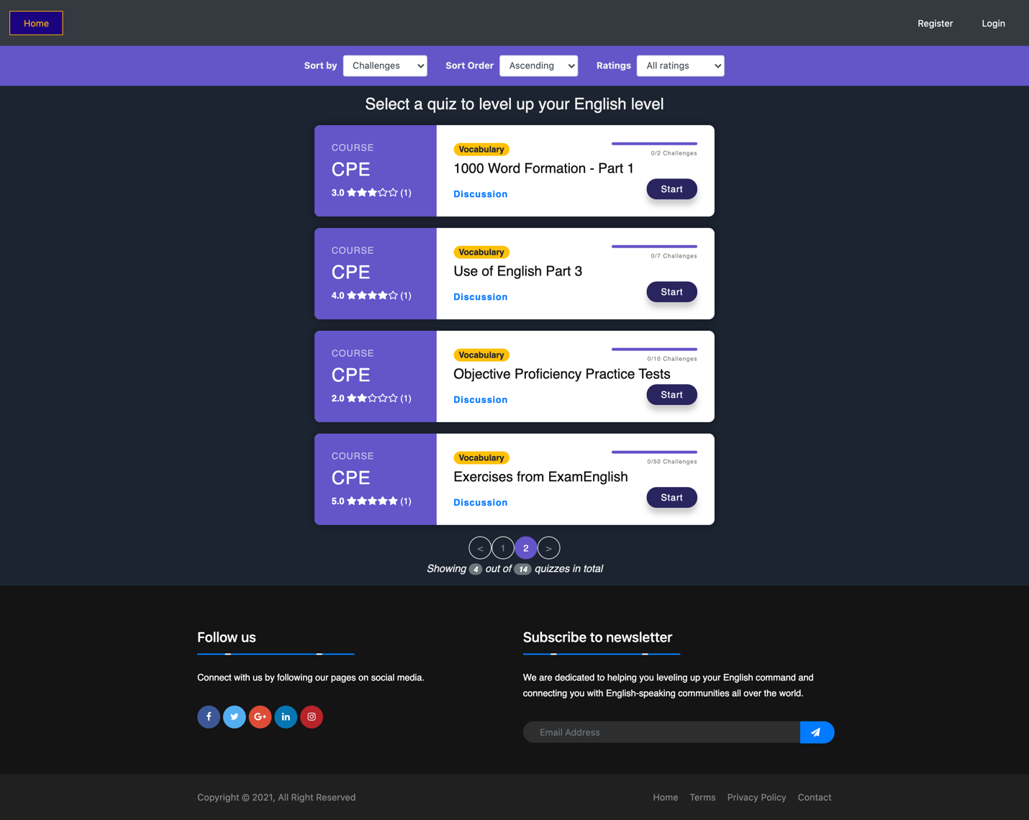

Figure : Home Screen - Unauthenticated user

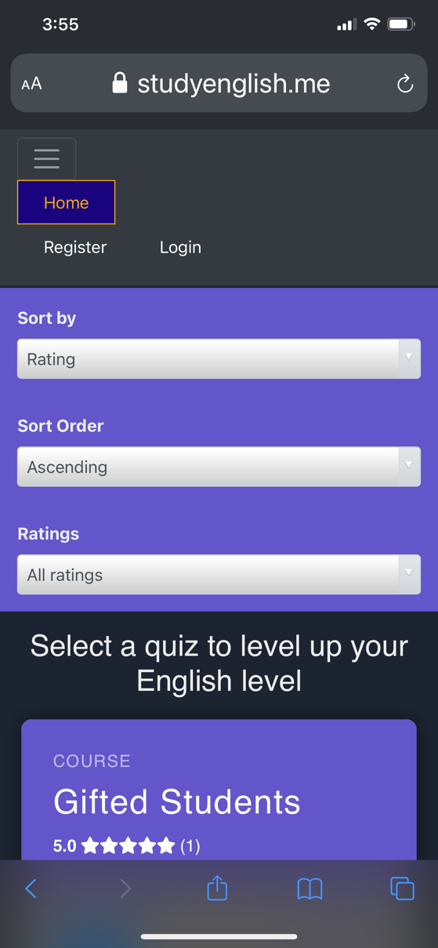

Figure : Home Page (Unauthenticated) - Mobile version

**Proposal:**

When a visitor arrives at the website, this is the first page that is presented to them. While what they see looks nice and appealing, they are not allowed to start one of these quizzes by clicking on either “Discussion” link or “Start” button until they have registered and become a student of the site. If visitor tries clicking one of these links and buttons, the site will redirect them to the Login screen start the authentication process. Likewise, if they try to access one of protected routes that are intended for registered students and teachers, such as /teacher or /statistics, the site will redirect the student to the login screen and ask student to authenticate themselves.

The reason login and register screens are not set as the entry point of the application is attributed to the fact that visitors should have a good idea of what the site is about before deciding to register. Additionally, even though there are many items in the navigation bar, they are hidden as the student is not currently authenticated.

**Changes from proposal:**

* Added skill names like Listening, Reading, or Vocabulary in badge to make it look more attractive.
* Added sort, filter and pagination for quizzes in this home page which had not been mentioned in proposal.

### Footer

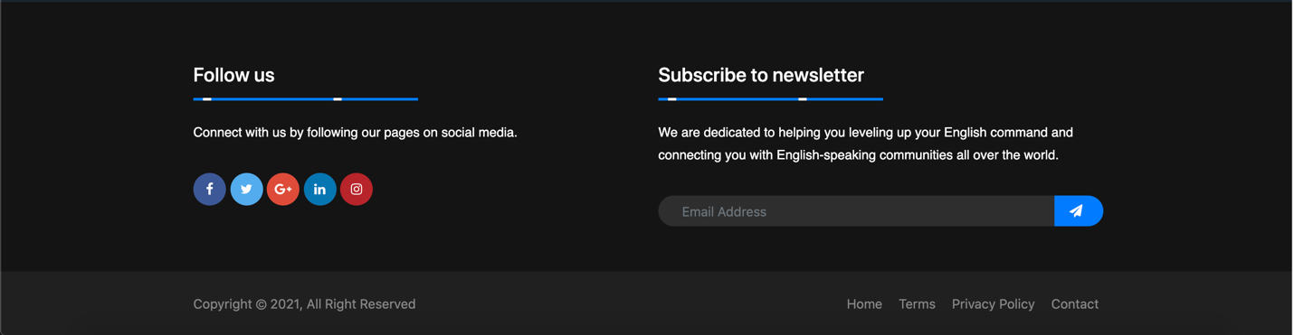

Figure : Footer

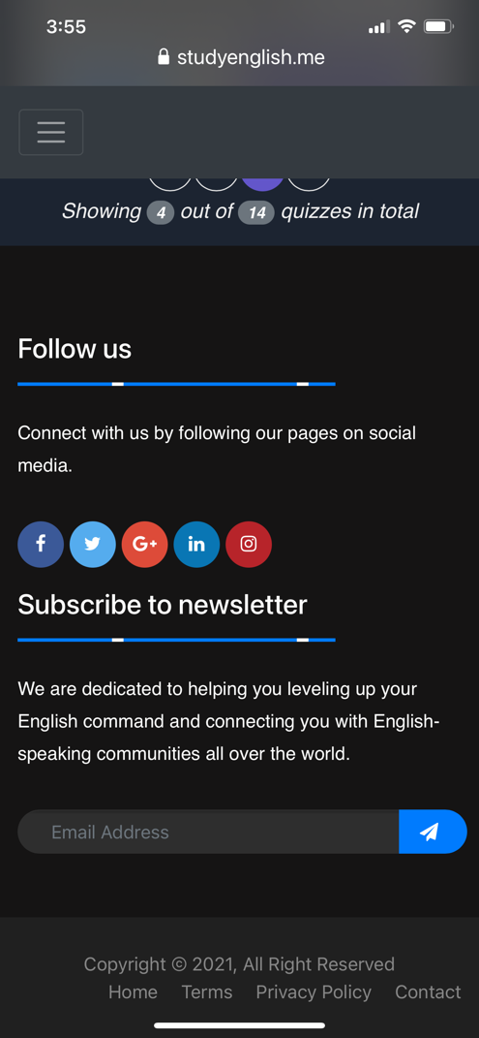

Figure : Footer on mobile screen

**Proposal:**

In the bottom of the site lies the footer where site information is located along with social media links.

**Changes from proposal:**

* Added an animation bar, some texts and input box for email to make the app look less boring.
* Added footer bottom bar containing “All Right Reserved” and some links to make the footer more professional.

### Home Screen (Authenticated)

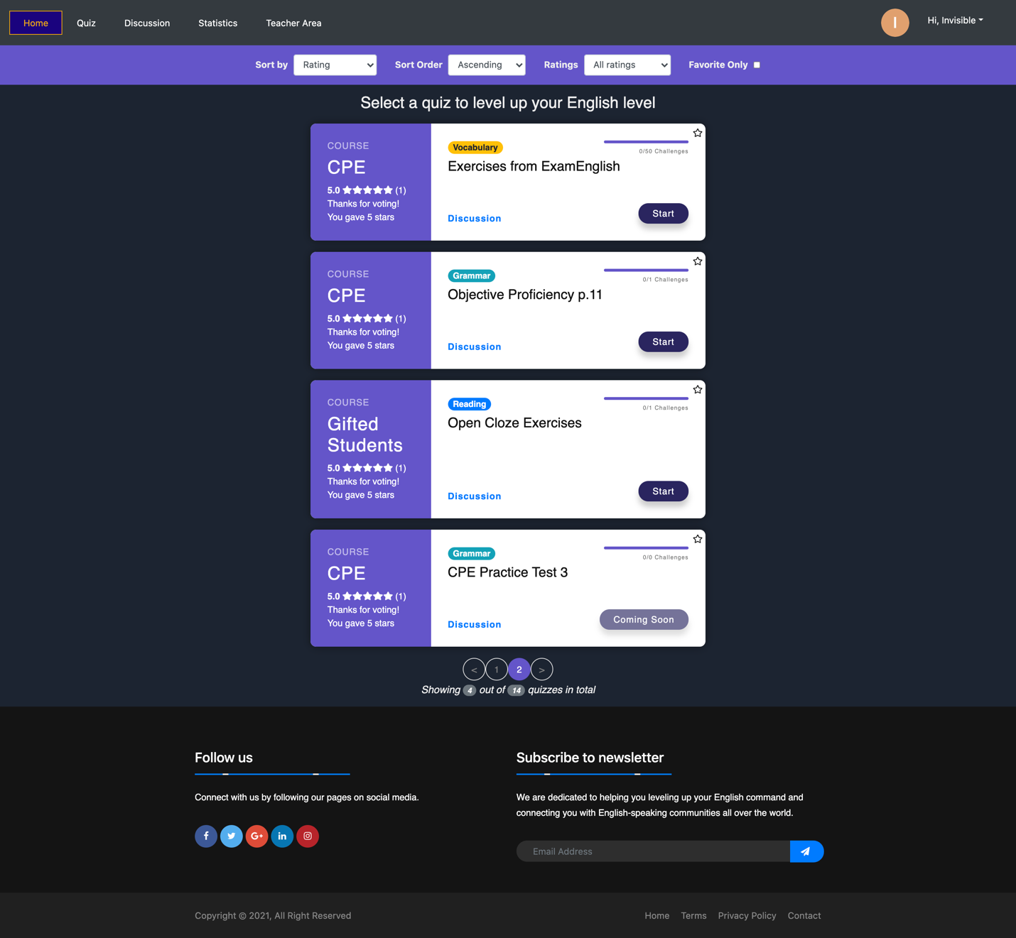

Figure : Home Screen - Authenticated

**Proposal:**

This is the home screen when student has successfully logged in their account. Unlike when student is unauthenticated, the “Login / Register” button on the right-hand side of the navigation bar is replaced with a greeting message along with the student’s profile picture and a dropdown button, which will be discussed later in this document. In addition to these changes, a new status bar that displays a brief overview of student statistics now appears under the navigation bar. Information about the numbers of completed and incomplete quizzes, the average accuracy of their answers, and the total amount of time spent on these quizzes is displayed inside the status bar. If student clicks on one of these numbers, the site will redirect them to the student statistics screen, where they are presented with detailed information about their performance over time. The router link to the student statistics screen is in the navigation bar and will be displayed and discussed later.

Furthermore, when student is authenticated, they are allowed to add any of the quizzes to favorites by clicking on the star in the top-right corner of the quiz card. Also, their progress on each quiz that they have taken are reflected in a progress bar on that quiz card as well.

**Changes from proposal:**

* Information about their performance should be viewable now in Statistics. This is because putting such data in Home Page would make the UI less intuitive.

## Register Screen

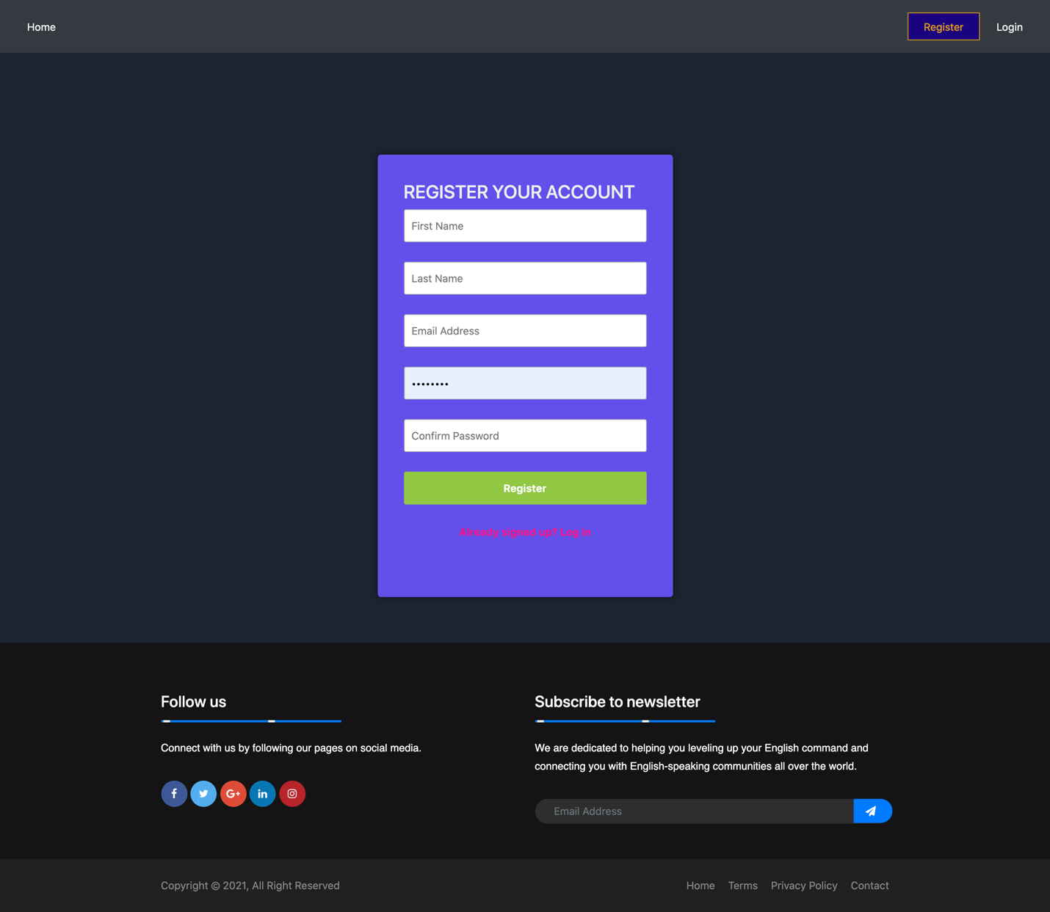Figure : Register Screen

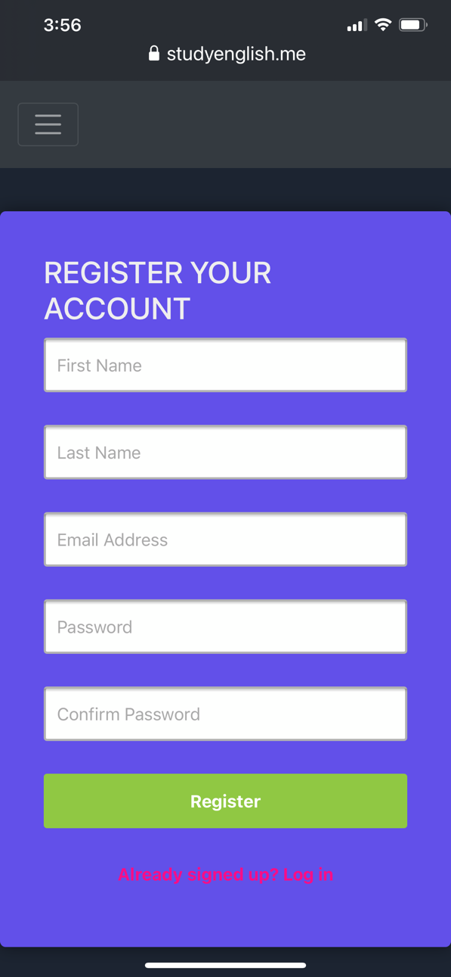

Figure : Register Page on mobile

**Proposal:**

When visitor first arrives and clicks on the Register button in the top-right corner, a new modal will open up and asks for basic information, like email and password. There will be validation to ensure the following requirements are met:

* Email has not been taken by any other student
* Email must be in the proper format (using regex to achieve)
* Password must be at least 8 characters
* Confirm password must be matched with password

If any of these requirements is not satisfied, an error message in red will display above the input form where student makes mistake and ask student to re-enter that information.

If all information entered by student is good, a new student will be registered and they will log in as the student, and at the same time, the site will redirect them to the home screen where they can begin their journey.

In case student clicks on “Already signed up? Log in”, the site will replace the Register modal with the Login modal.

**Changes from proposal:**

* Added input fields for first name and last name and made them required since they are important to Discussion and Statistics.
* Validations for first name and last name have been implemented as well.

## Login Screen

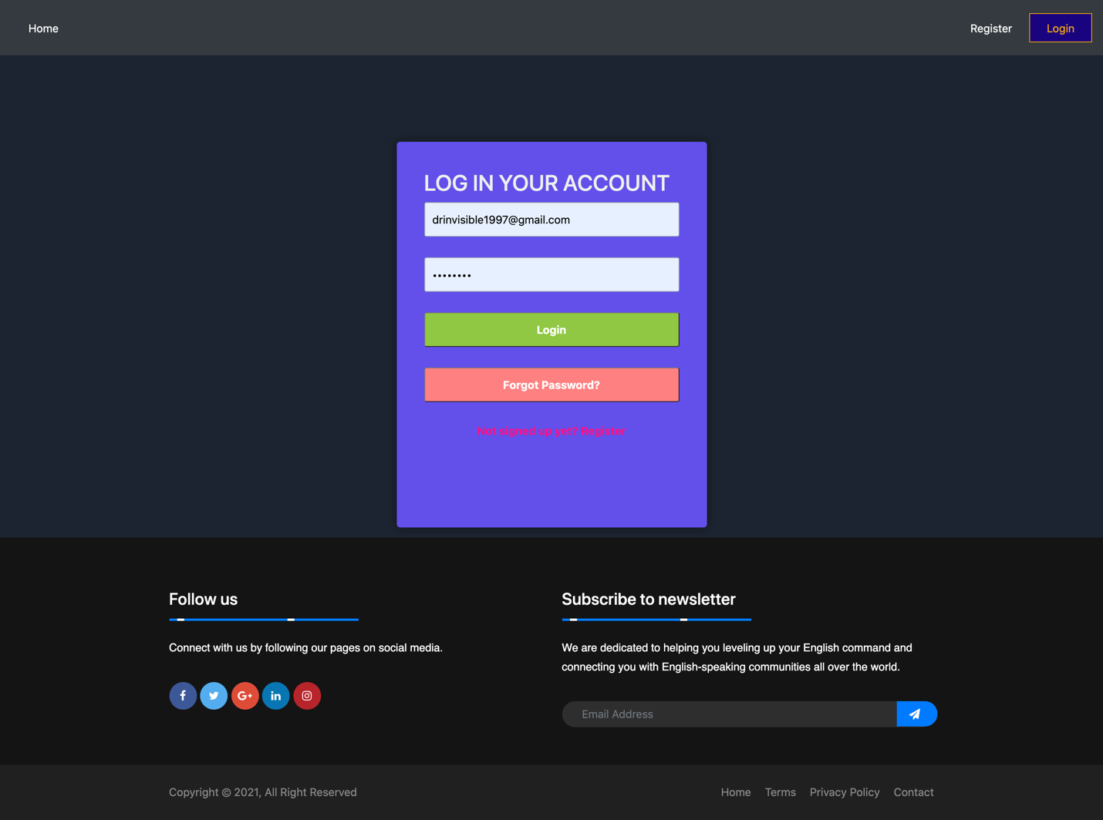

Figure : Login Screen

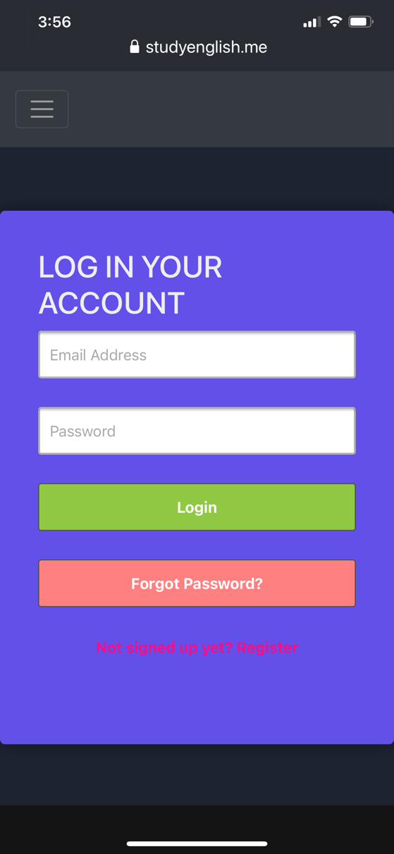

Figure : Login Page on mobile

**Proposal:**

This is the Login modal where student enters information, including email address and password that they have entered when registering their account, to log in their account. There is also validation that makes sure that the following requirements are met:

* Email must be in the proper format (using regex to achieve)
* Password must be at least 8 characters

Like the Register screen, error message will appear and asks student to re-enter their information if either of them is incorrect.

If student has not registered their account, they should do so by clicking the link “Not signed up yet? Register” in the bottom of this modal.

If student has forgotten their password, they can set a new password by clicking on the “Forgot Password?” button and follow the instruction in that screen, which will be discussed later.

If everything is all good, student will be redirected to Home Screen after clicking on the Login button.

**Changes from proposal:**

* No significant changes from the proposal

## Forgotten Password

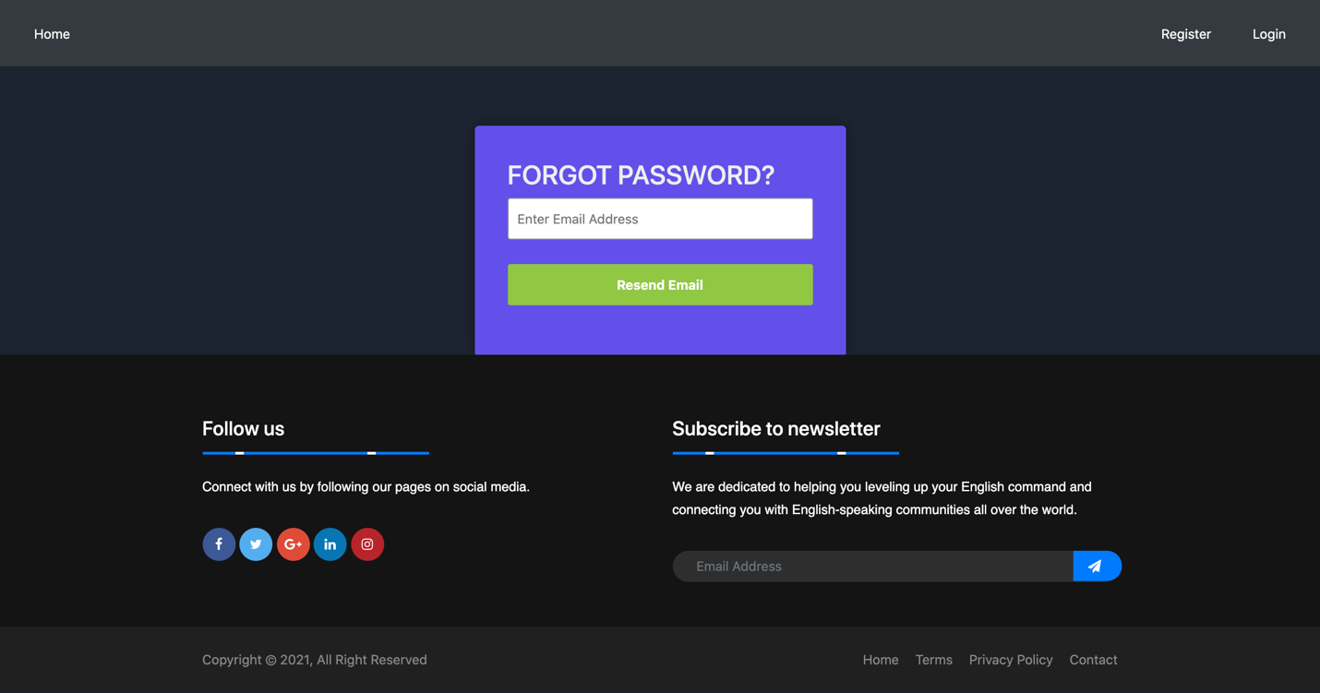

Figure : Forgotten Password

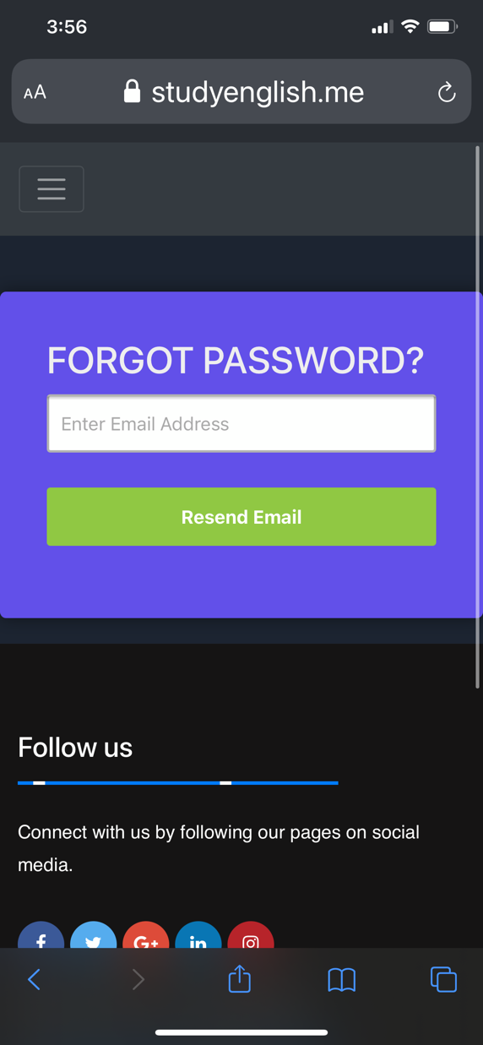

Figure : Forgot Password screen on mobile

**Proposal:**

This screen can be accessed from the Login Screen. When user has forgotten their password, they can request to change password by entering their email and clicking on the “Submit” button. As soon as they have clicked on the “Submit” button, a newly generated random will be sent to their email, and they should be able to log in the application using the password.

**Changes from proposal:**

* No significant changes.

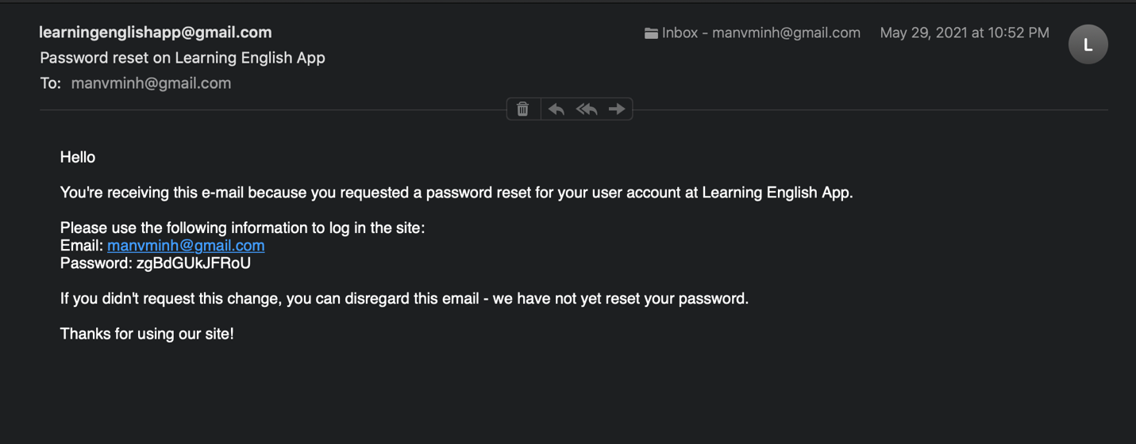

Figure : Email resetting password has been received

## **View User Profile Dropdown Menu**

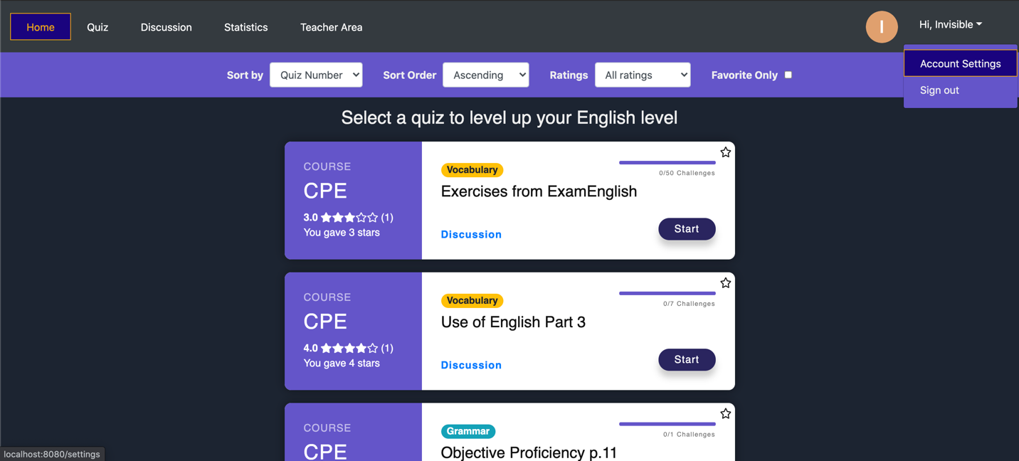

Figure : User Profile Dropdown Menu

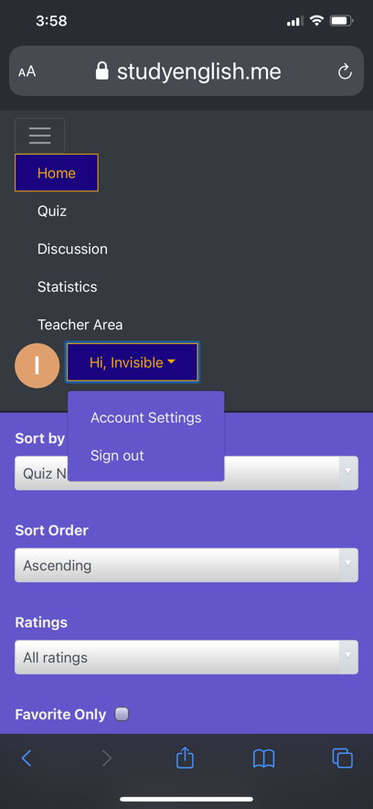

Figure : User Profile Dropdown Menu on Mobile

**Proposal:**

When student clicks on the dropdown menu in the top-right corner, two options will pop up. Student or teacher can choose to edit their information like email, first name, last name or password or they can choose to sign out.

**Changes from proposal:**

* “Personal Information” has been renamed to “Account Settings”

## **Profile Settings Screen**

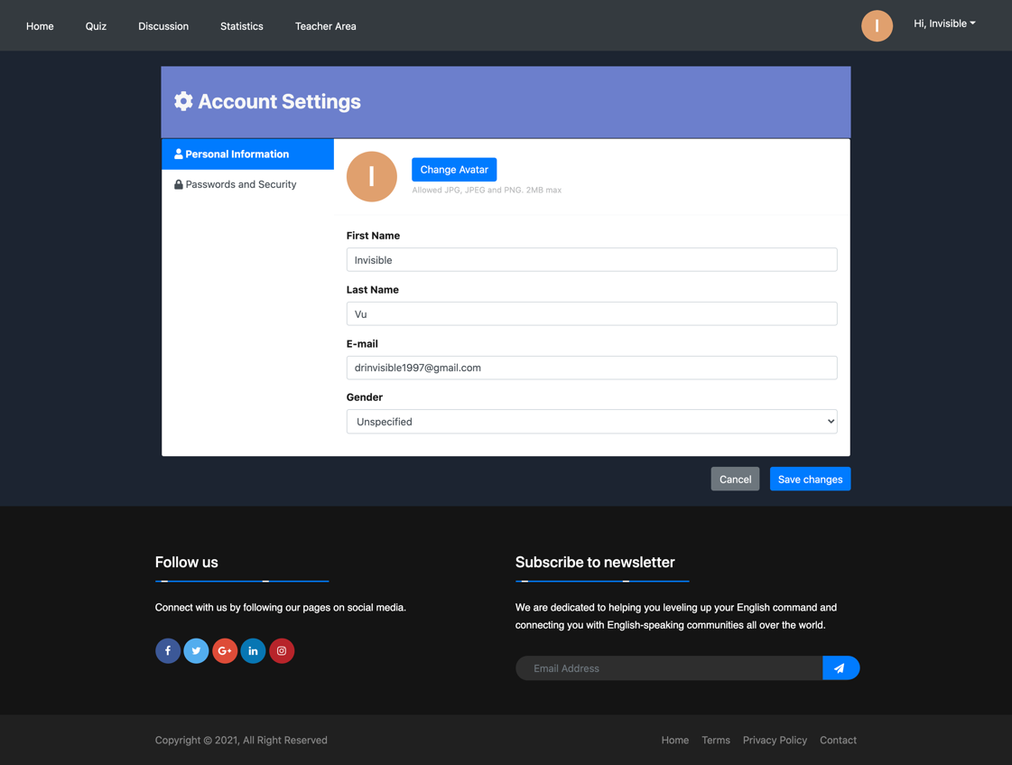

Figure : Account Settings - Personal Information

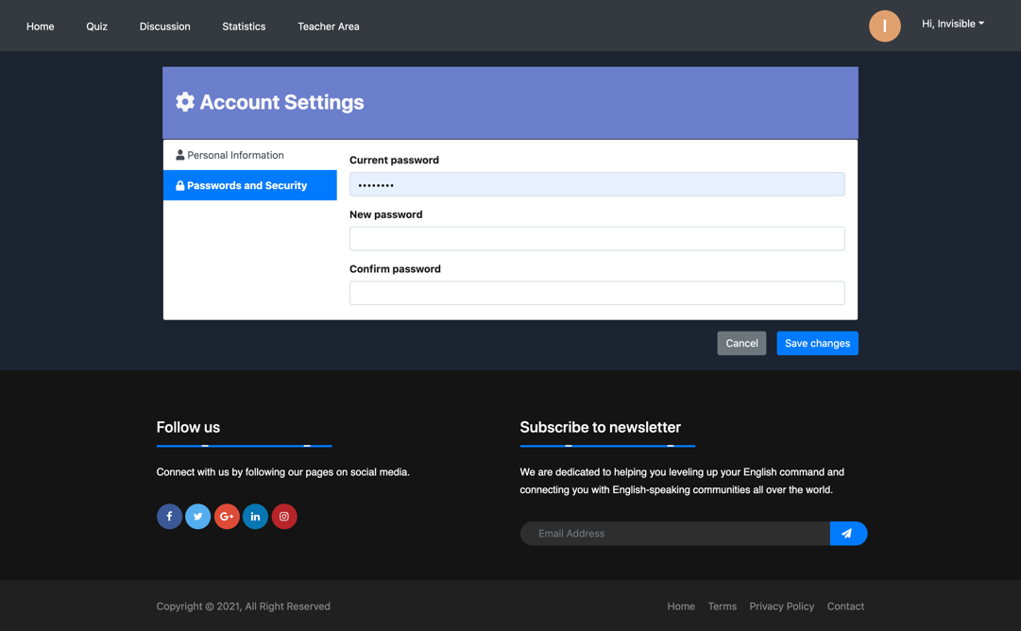

Figure : Account Settings - Passwords and Security

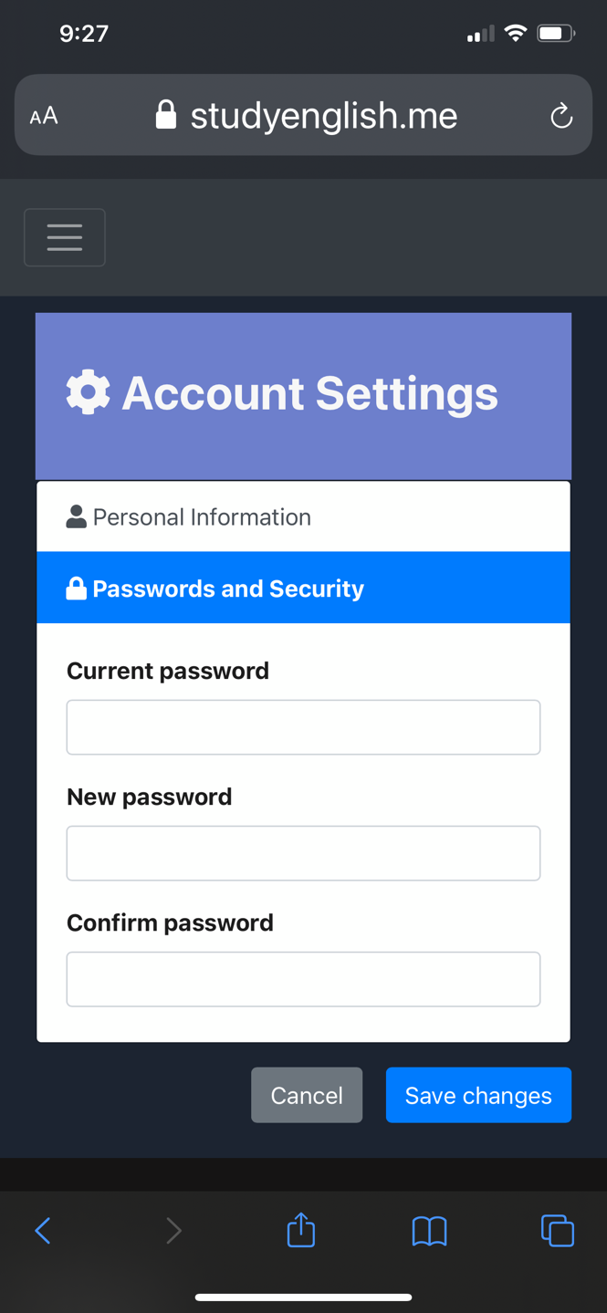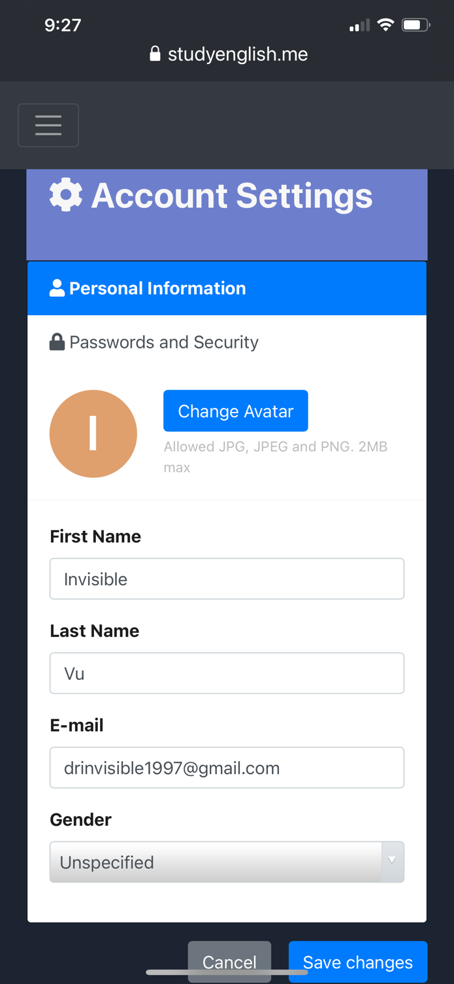

**Proposal:**

Student or teacher can access this screen by clicking on “Profile Information” in the dropdown box beside the profile picture. In this screen, student can change their basic personal information.

However, the information entered by student has to conform with the requirements in the Register screen. Also, the first name and last name input forms cannot be left blank.

**Changes from proposal:**

* Account Settings now has two tabs instead of only one like in the proposal
* User can change their Avatar which is uploaded to AWS Bucket
* Validations have been implemented for these fields

## **Quiz Screen**

### **Quiz Screen (Multiple Choice Question)**

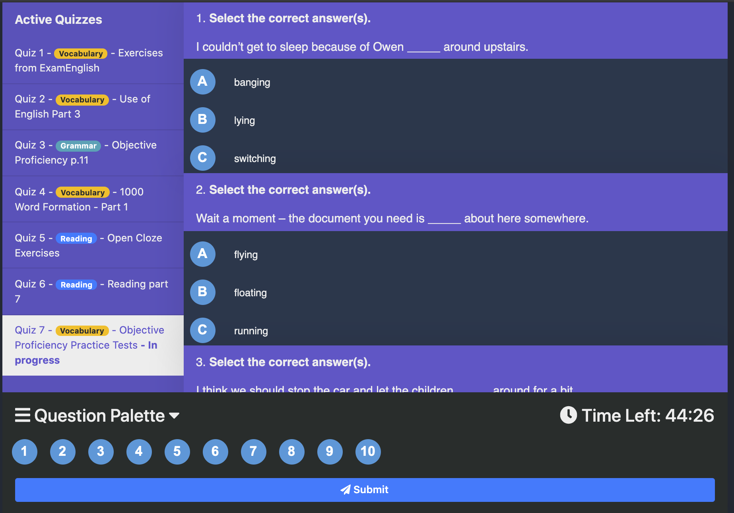

Figure : Quiz Screen - Multiple Choice Question

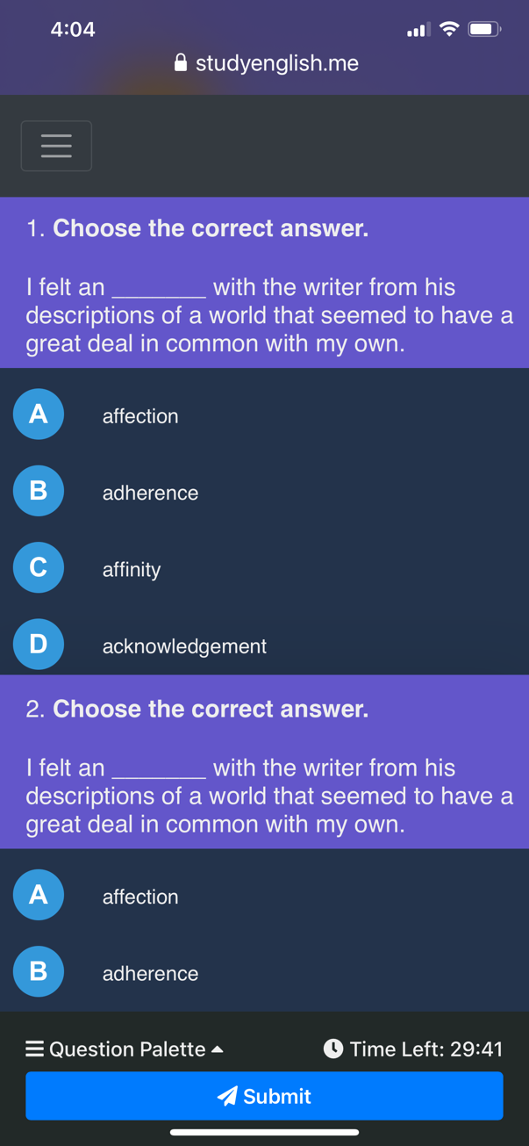

Figure : Multiple Choice question on mobile

**Proposal:**

This is the main screen that hosts the implementation of the core functionality of this application.

In the left sidebar of the page, student is suggested with quizzes that they have not taken. Clicking on one of these quiz links will pop up a message that asks student whether they really want to save their current attempt for the current quiz and switch to the selected quiz.

In the right sidebar of the page, there is a countdown timer that displays the number of minutes or seconds left until the end of the current attempt. As soon as the timer hits 0 second left, the site will automatically all of their answers no matter whether student has answered or not. Below the timer is the question palette and you can navigate to the question number that they want by clicking on one of the numbers in the palette. Also, another important item is the Submit button. If student clicks on the button, they will be asked whether or not they want to submit their work because this action cannot be undone. If student clicks on Yes, they will immediately see the result of their attempt along with their correct and incorrect answers.

This center of the screen houses the main body of the page, the quiz part. One of the most common question types is multiple choice, and this one is the most simple and straightforward, so this will be introduced and discussed first. Each of the multiple-choice questions is presented in a question card that includes the header and body part. While the header contains the instruction and question, all of the choices are listed in the body part. As soon as student makes a choice, the selected option will be highlighted and the quiz will be saved just in case the student disconnects from the site.

In case of disconnection, student can reconnect and resume their current attempt without having to start over and the time remaining continues to decrease without being reset.

**Changes from proposal:**

* Question palette has been moved to a sticky position in the bottom of the page, leaving space for long paragraphs and lengthy questions. The changes have been made to both desktop and mobile versions.
* Question palette has an ability to collapse and expand on its own at will
* Similar quizzes have been renamed to “Active Quizzes” and now displays more about the current attempts and the quizzes themselves.

### **Quiz Screen (Gap filling Question)**

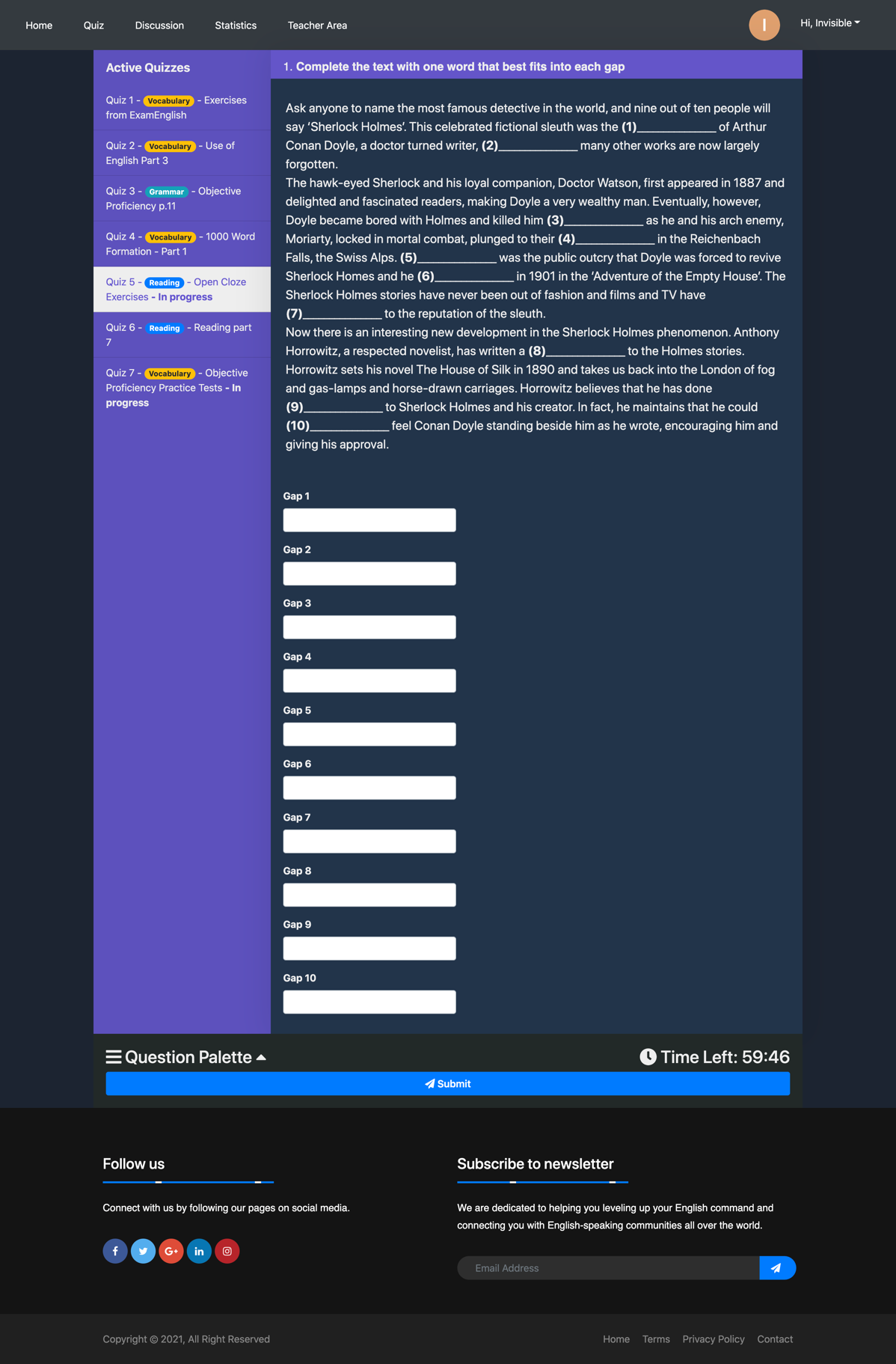

Figure : Quiz Question - Gap-filling question

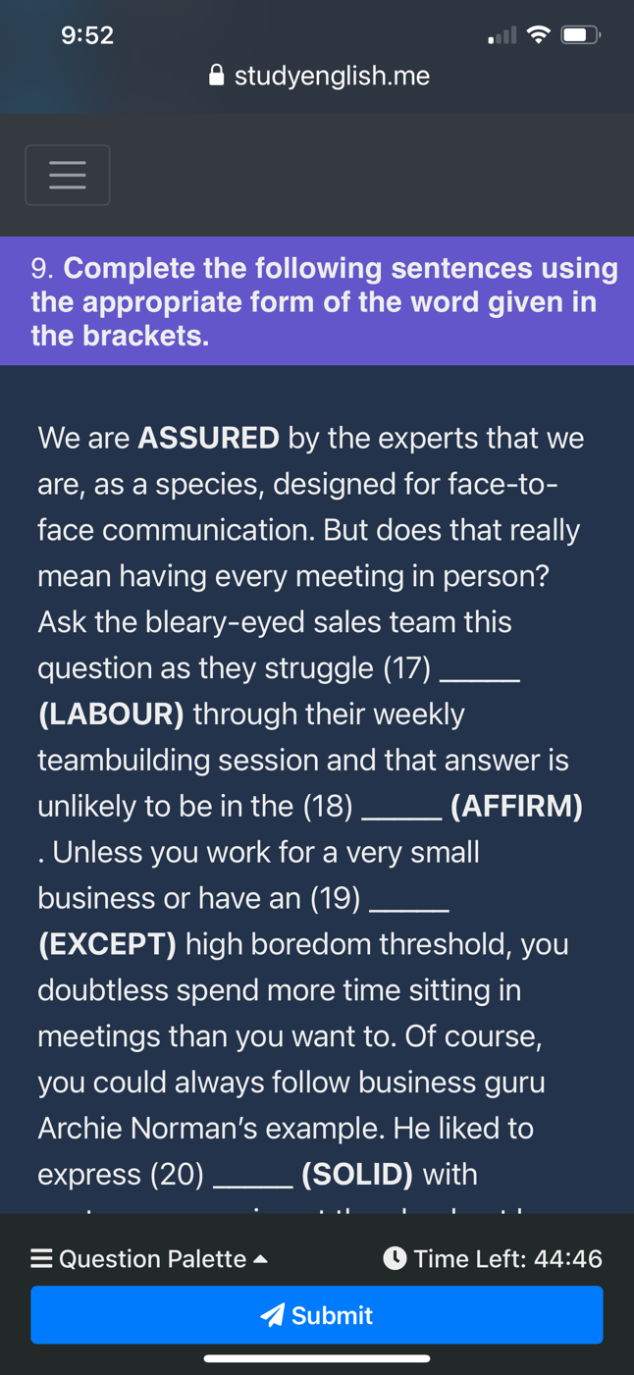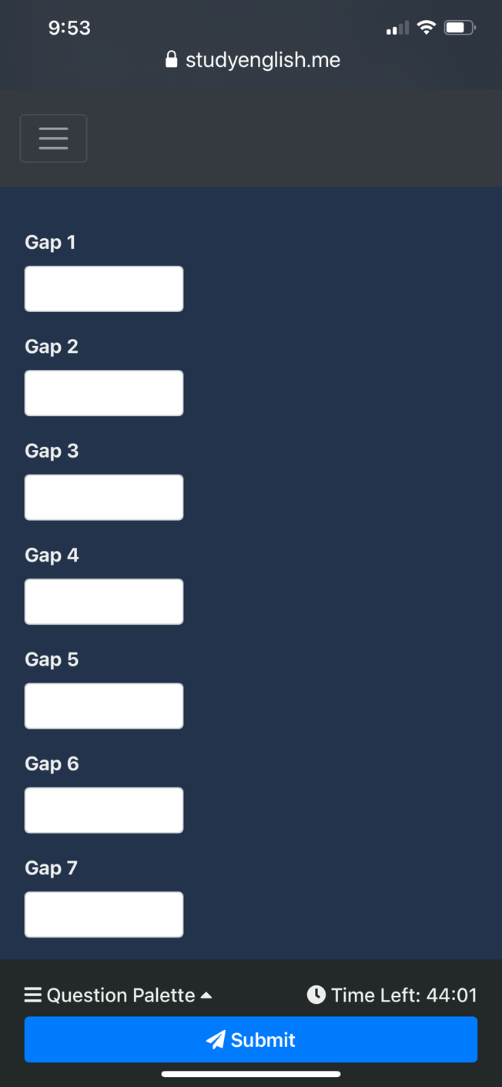

**Proposal:**

As for the gap-filling questions, student is presented with instruction for the question in the header the question card, a paragraph or sentence with blanks with numbers and the text boxes for entering their answers below the question header. There is no validation for these input text boxes because answer can be text or numerical, which is determined by the teacher who has created the quiz. Additionally, student’s answers are saved on the server side every time student triggers key-up event of each of the textboxes.

**Changes from proposal:**

* Paragraph display now supports HTML elements, allowing texts to be bold, italic or underline depending on how the teacher enters
* In the future, these gaps will be placed directly in the paragraph text for better aesthetic quality and better

### **Quiz Screen (Matching Question)**

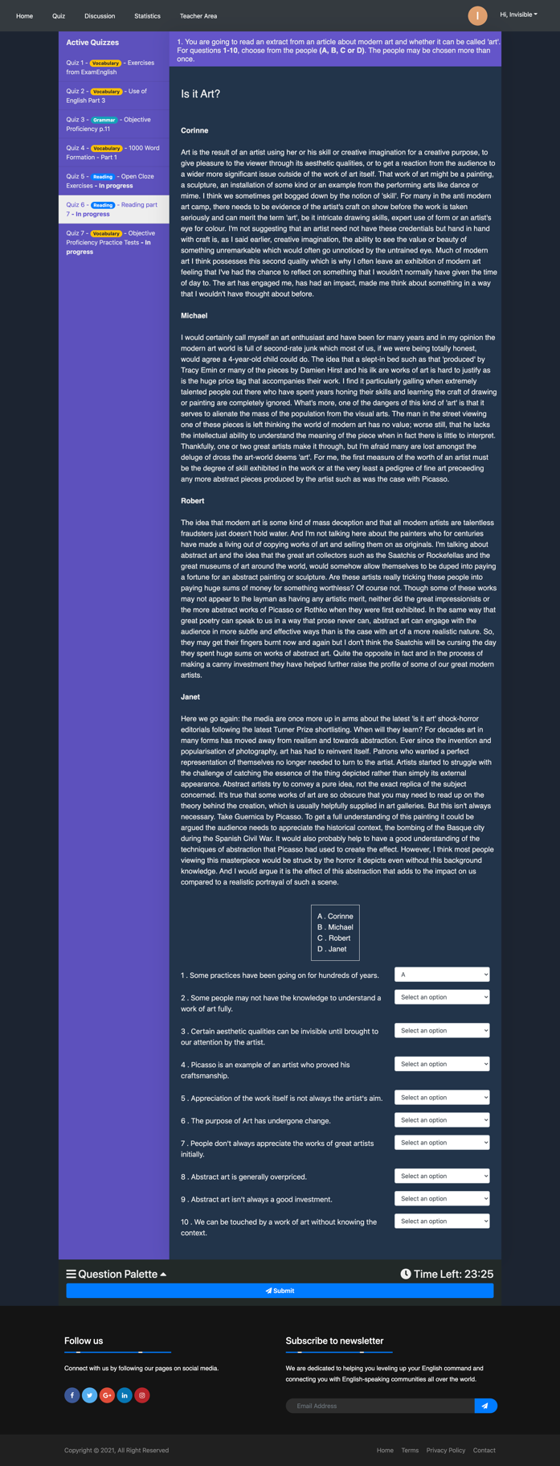

Figure : Quiz Screen - Matching Question

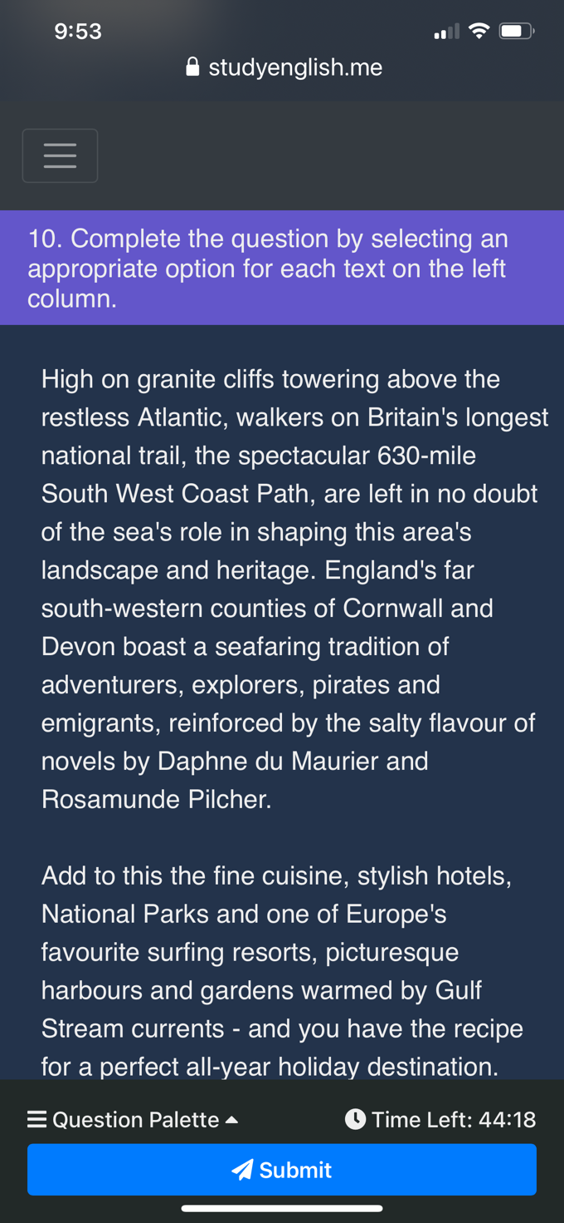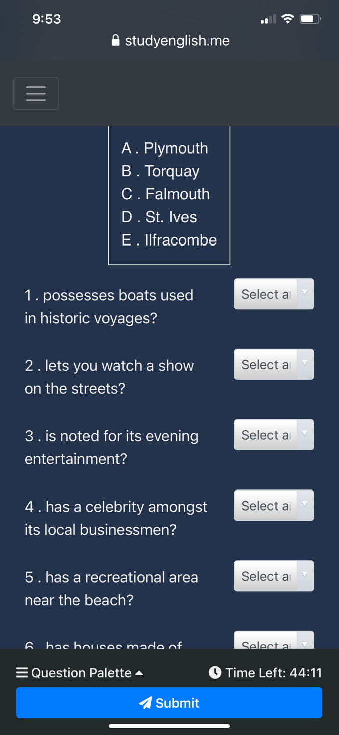

**Proposal:**

In regards to the matching questions, student is presented with instruction for the question, paragraph that contains information to answer the questions. Below the paragraph is an option box that contains a list of available options, each of which is assigned a letter for identification. Below that is a list of questions and there is a dropdown box associated with each of the questions. The dropdown boxes contain all available options in the option box above it. Student or teacher answers by choosing the most suitable option for each question. Also, student’s answers are saved on the server side every time student triggers key-up event of each of the textboxes.

**Changes from proposal:**

* Like gap-filling questions, paragraph display now supports HTML elements, allowing texts to be bold, italic or underline depending on how the teacher enters

### **Quiz Result Screen**

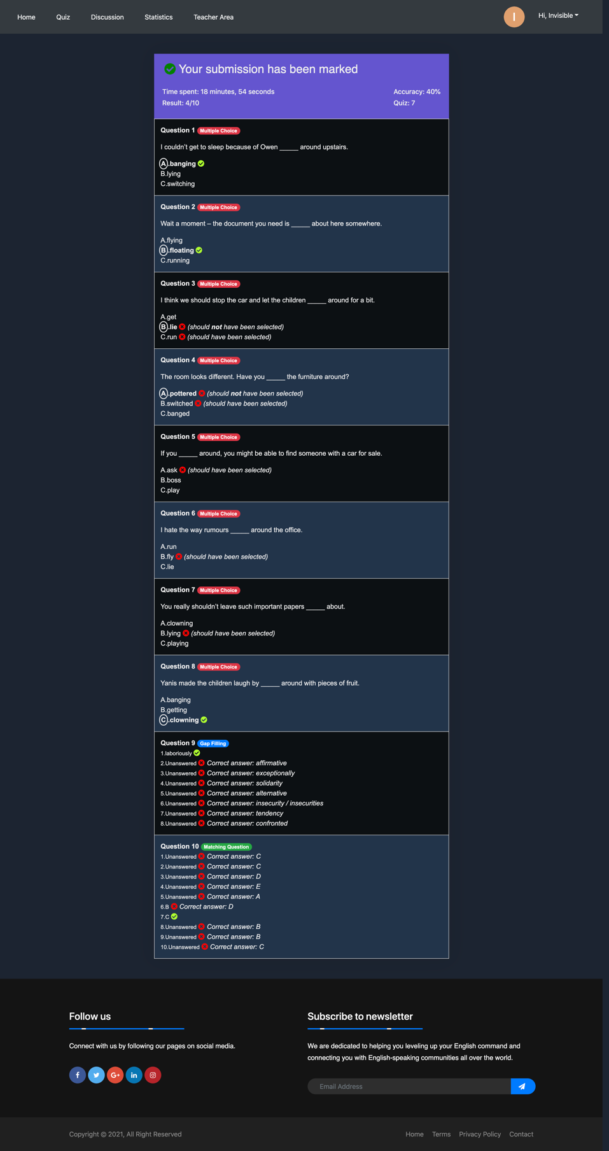

Figure : Quiz Result Screen

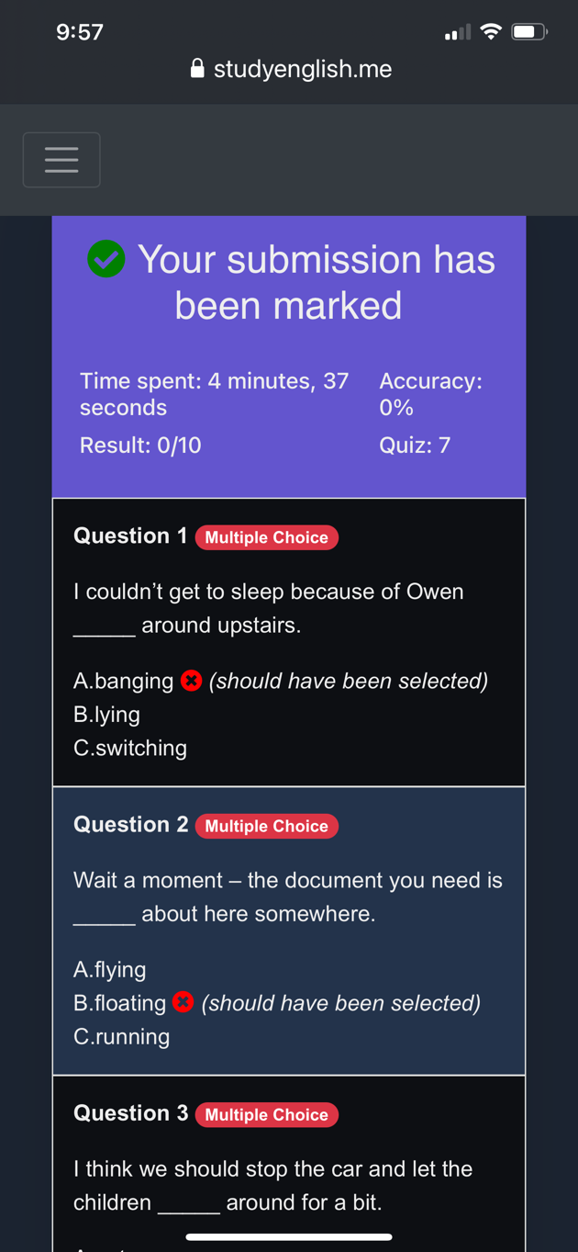

**Proposal:**

This is the Quiz Result screen which will appear after student has submitted their quiz. Using this screen, they can see which answers are marked correct and incorrect.

**Changes from proposal:**

* UI has been greatly improved since the proposal. More elements have been added to show correct and incorrect answers.

## **Discussion Forum**

### **Main Screen**

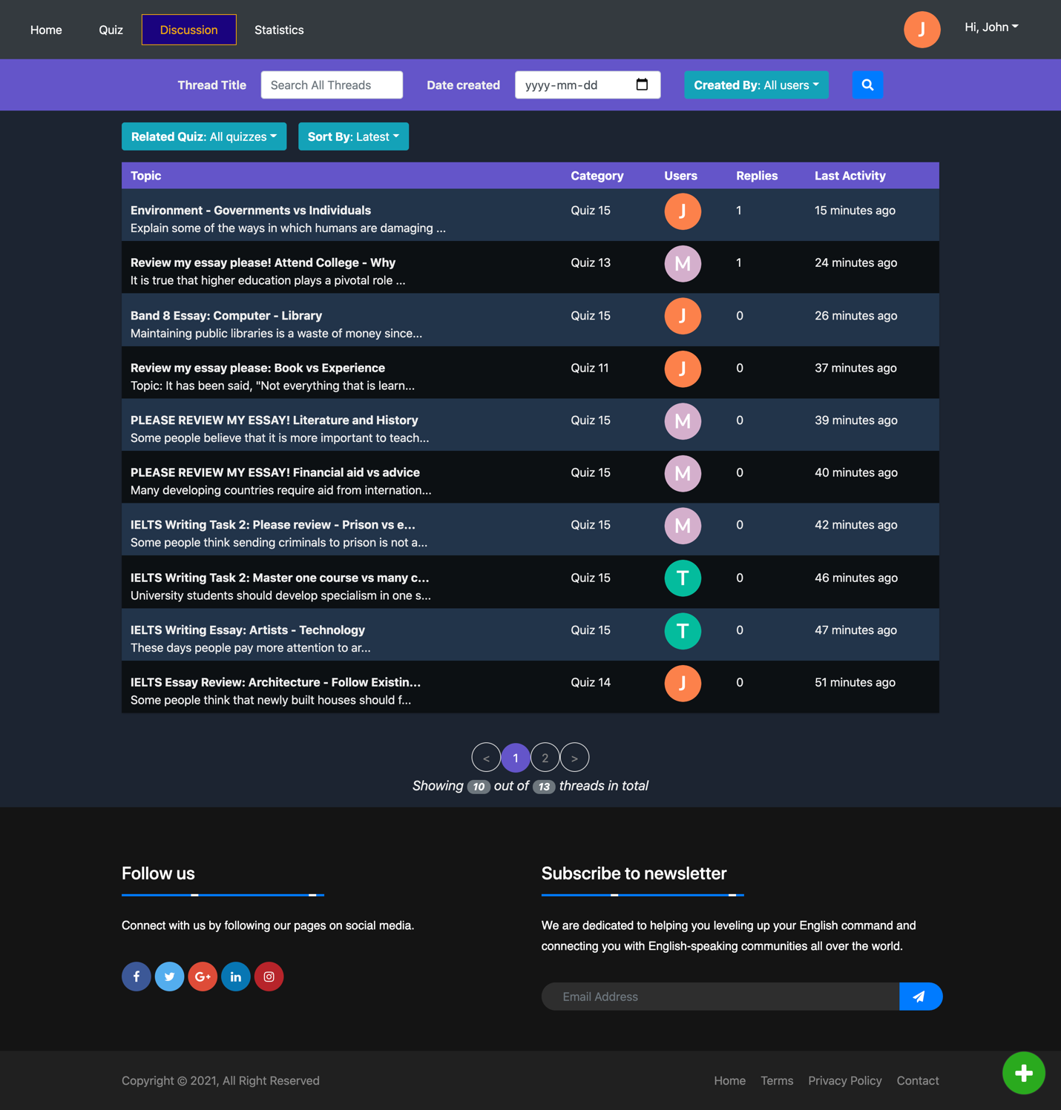

Figure : Discussion Forum - Main Screen

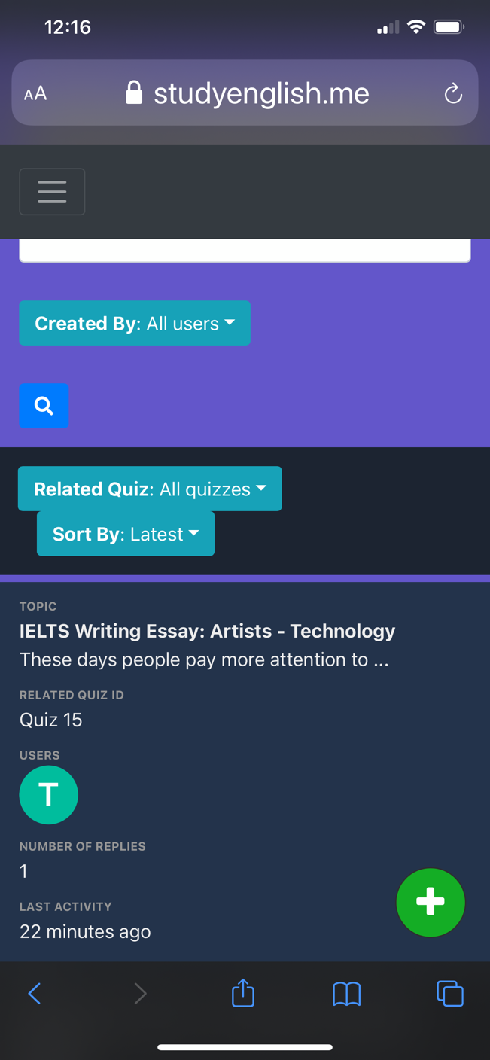

Figure : Discussion Forum - Some Threads

**Proposal:**

This is the main page of the discussion forum. Student or teacher can access it by a couple of different ways, one is by the navigation bar and the other is clicking on the discussion link on any quiz card in the Home screen. The second method triggers the site to pre-filter the topic by category is related to the quiz number that student has selected. For example, if student has selected the “Discussion” link in the quiz number two, they will be presented with a list of threads that are related to quiz two only. Also, the category dropdown box is assigned “Quiz 2” as well in this case.

Using this discussion forum screen, student can apply multiple filters that allow for scalability and flexibility. They can do so by entering the keyword for searching threads, the name of the people who have created threads, and the created date of the threads in the top bar of the site. As soon as they are happy about the filters, they can perform a search by clicking on the Search button. Following this, the list of discussion threads below will be filtered by the predicate student has set.

As for sorting search results, discussion threads are sorted by last activity time by default. However, student can sort by the oldest threads and threads with most replies by clicking on one of sorting by texts, including “Latest”, “Oldest” and “Most Replies”.

Discussion threads are listed along with their category which are quiz numbers they are related to. Also, the profile pictures of students who have participated in threads are listed in the Users column. Each thread also has the number of replies and the last activity time which is the date time of the last reply to the thread.

If student wants to read a thread, they can click on the title of the thread, and then they will be redirected to the Thread screen, which will be introduced and discussed later.

If student would like to create a new thread, they can click on the big “+” button in the right bottom corner of the site, and they will be redirected to the Create Thread screen to create a new thread.

**Changes from proposal:**

* Some UI changes but most still remain the same

### **Create New Thread Screen**

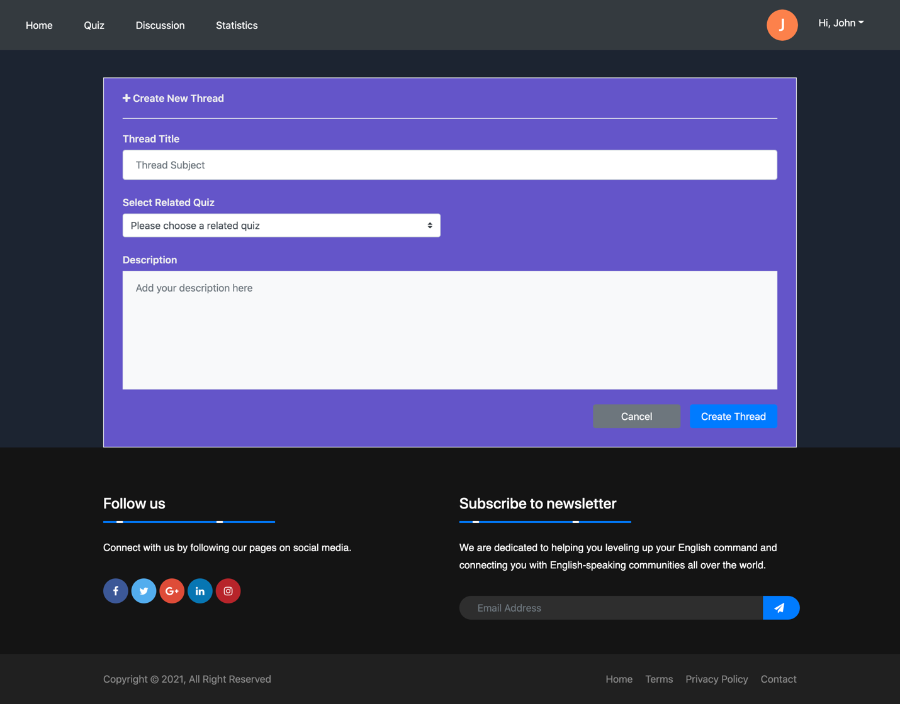

Figure : Discussion Forum - Created New Thread Screen

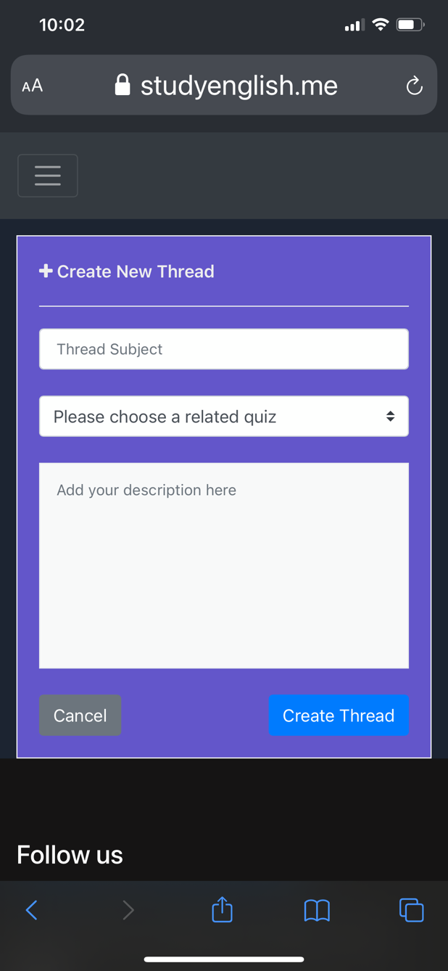

**Proposal:**

This screen appears as soon as student has selected the big “+” button in the main screen of discussion forum. This route is protected and visitors cannot access it without authentication first. On the top of the screen is page title “Create New Thread” to let student know that they are creating a new thread. Below the title are an input form that accepts text and numerical input and Category dropdown that is pre-fetched and pre-filled with all quiz numbers that are currently active. Below the “Description” is a text area that accepts multi-line input from student. What is entered in this text area will display exactly as it is in the Thread screen which is introduced in the next section.

The “Cancel” button will allow student to discard their all of their input and go back the main discussion forum, while the “Create Thread” will create a new thread with information entered by student.

**Changes from proposal:**

* No significant changes

### **Thread Screen**

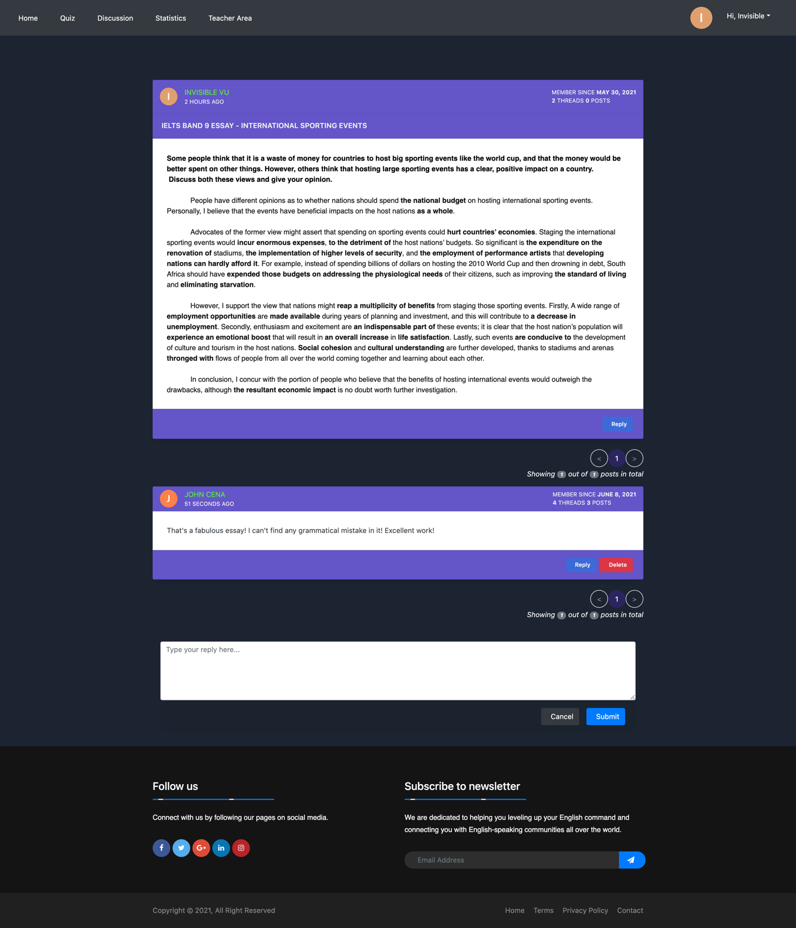

Figure : Discussion Forum - Thread Screen

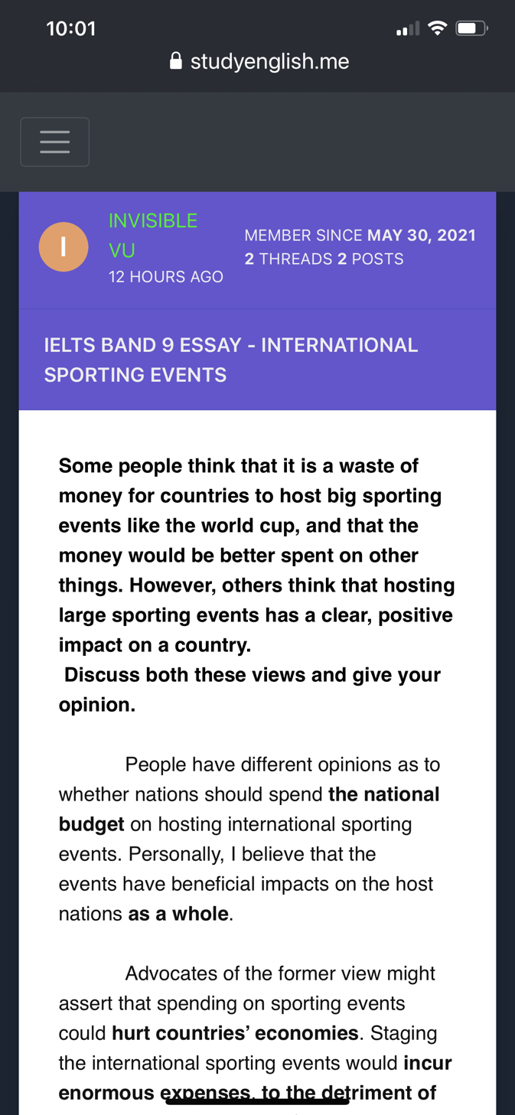

Figure : Thread content - mobile

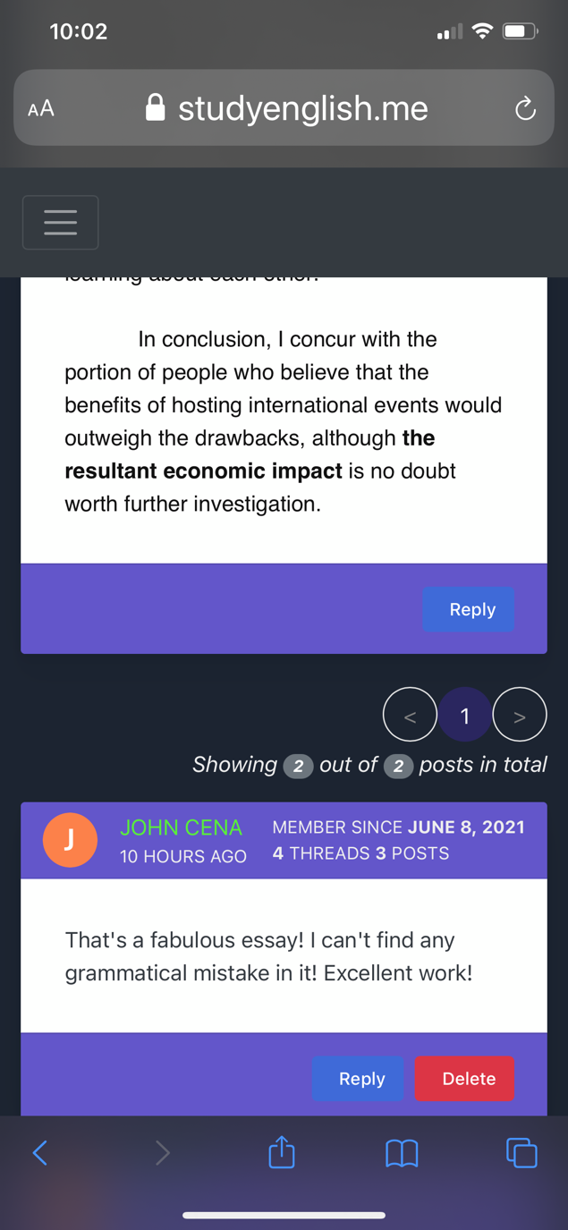

Figure : Post content

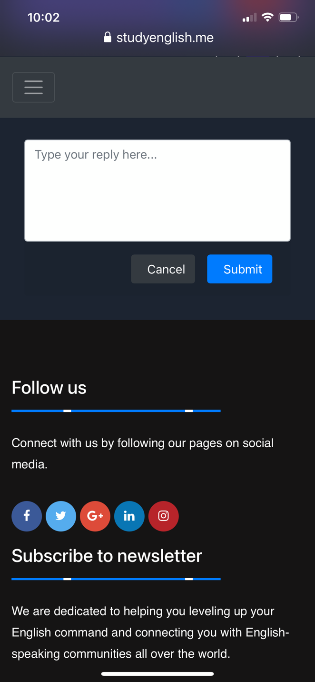

Figure : Reply box

**Proposal:**

This thread screen appears when student has just created a new thread or clicked on one of the topic titles in the main screen of discussion forum. The style of this screen is intuitive and easy to understand since it is developed as simple as possible to just provide core functionality of a discussion forum. More specifically, basic information about the owner of a thread or a post appears in the header section of their thread or post, while the main body contains the content of their thread or post and the bold text below the header section wraps the subject of this thread. Student or teacher can create post and reply to this thread by clicking on the “Reply” in the bottom right of the thread.

Only teachers can see the “Delete” button for each post, which allows them to remove posts that are considered inappropriate. If students are trying to fire a request to delete posts, they are prohibited from performing that action.

## **Student Statistics**

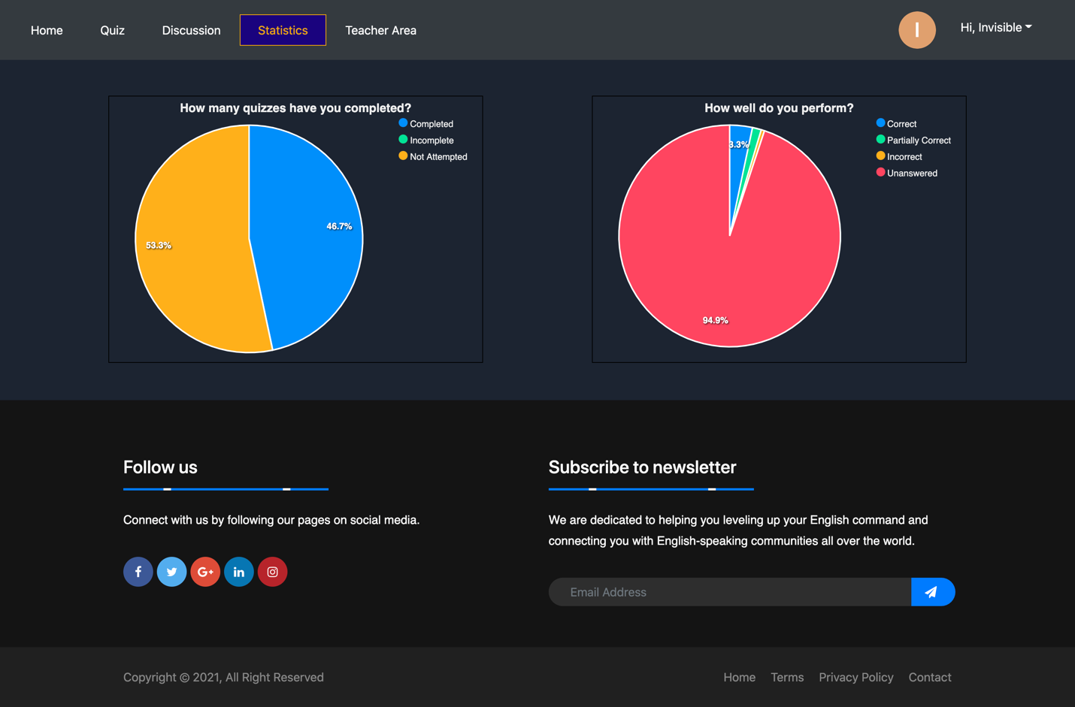

Figure : Student Statistics Screen

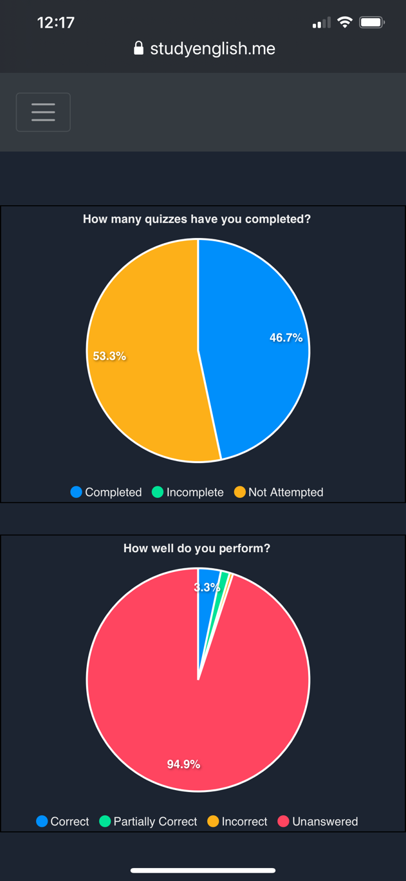

Figure : Student Statistics Screen

**Proposal:**

In this Student Statistics screen, students are able to view the numbers of completed, in progress and not attempted quizzes and the numbers of correct, incorrect, and unanswered responses to questions in the quizzes they have completed. Data is visualized in two pie charts.

## **Teacher Screen**

This is the teacher site of the page which is a protected route and can only be accessed by students with the “teacher” role. Students and visitors cannot either see “Teacher Area” on their navigation bar. There is a left sidebar in this screen which is Teacher Panel which allows teachers to easily create, update and delete quizzes and questions and view the overall statistics of the site.

### **Teacher Screen - Manage Quizzes**

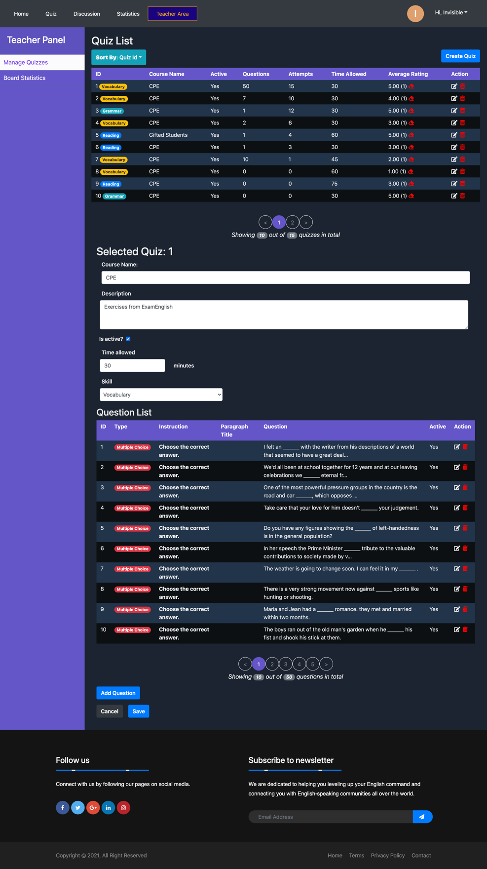

Figure : Teacher Screen - Manage Quizzes

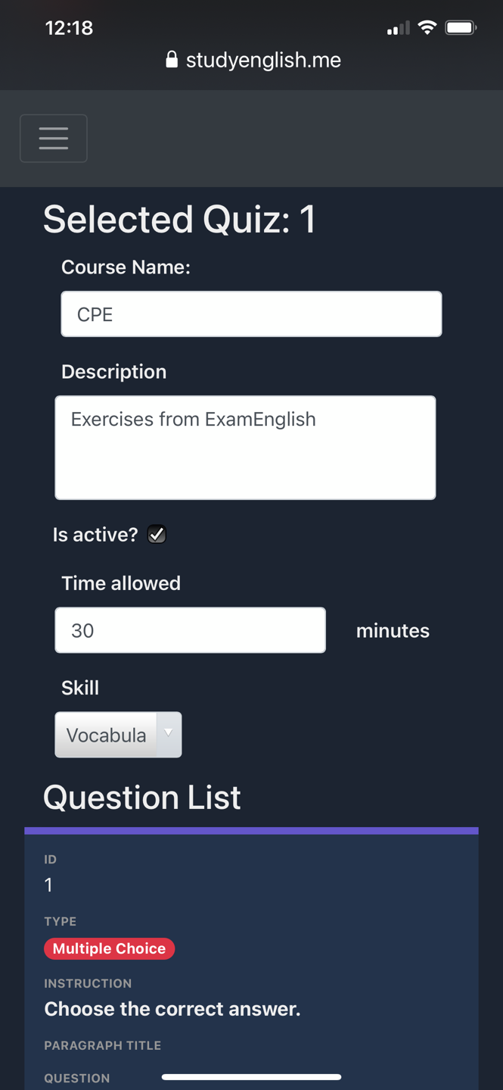

**Proposal:**

This is the default page teachers will see when they access the “Teacher Area” route. The list of all quizzes will be populated in the quiz list table, and if there are more than 10 quizzes in the database, they will display in paginated list with 10 items per page. Important information about each quiz appears in the table along with two buttons, edit and delete, which allow teachers to edit or delete quizzes.

If they click on the edit button of a quiz, all the details about the quiz will display in an editable form which is located below the quiz list, and the quiz number and course name will display after the “Selected Quiz” text. Active quizzes will display in the home page and can be taken by students, while inactive are hidden and inaccessible.

If there is no question has been created for the quiz, the text “There is currently 0 question in the quiz” will display.

There will be a button placed next to every quiz that allows teachers to reset their ratings given by students.

If there are questions in the quiz, they will display in table format. Like the quiz list, if there are more than 10 questions in the quiz, they will display in paginated lists for the sake of scalability. There are also edit and delete buttons associated with each question that allow teachers to either edit and delete the question.

**Changes from proposal:**

* Average ratings column has been added to quiz list. The little eraser button beside it will reset ratings for a quiz
* User is only allowed to add a new question only when the quiz has been created or in edit mode.

### **Teacher Screen – Add/Edit Question – Multiple Choice**

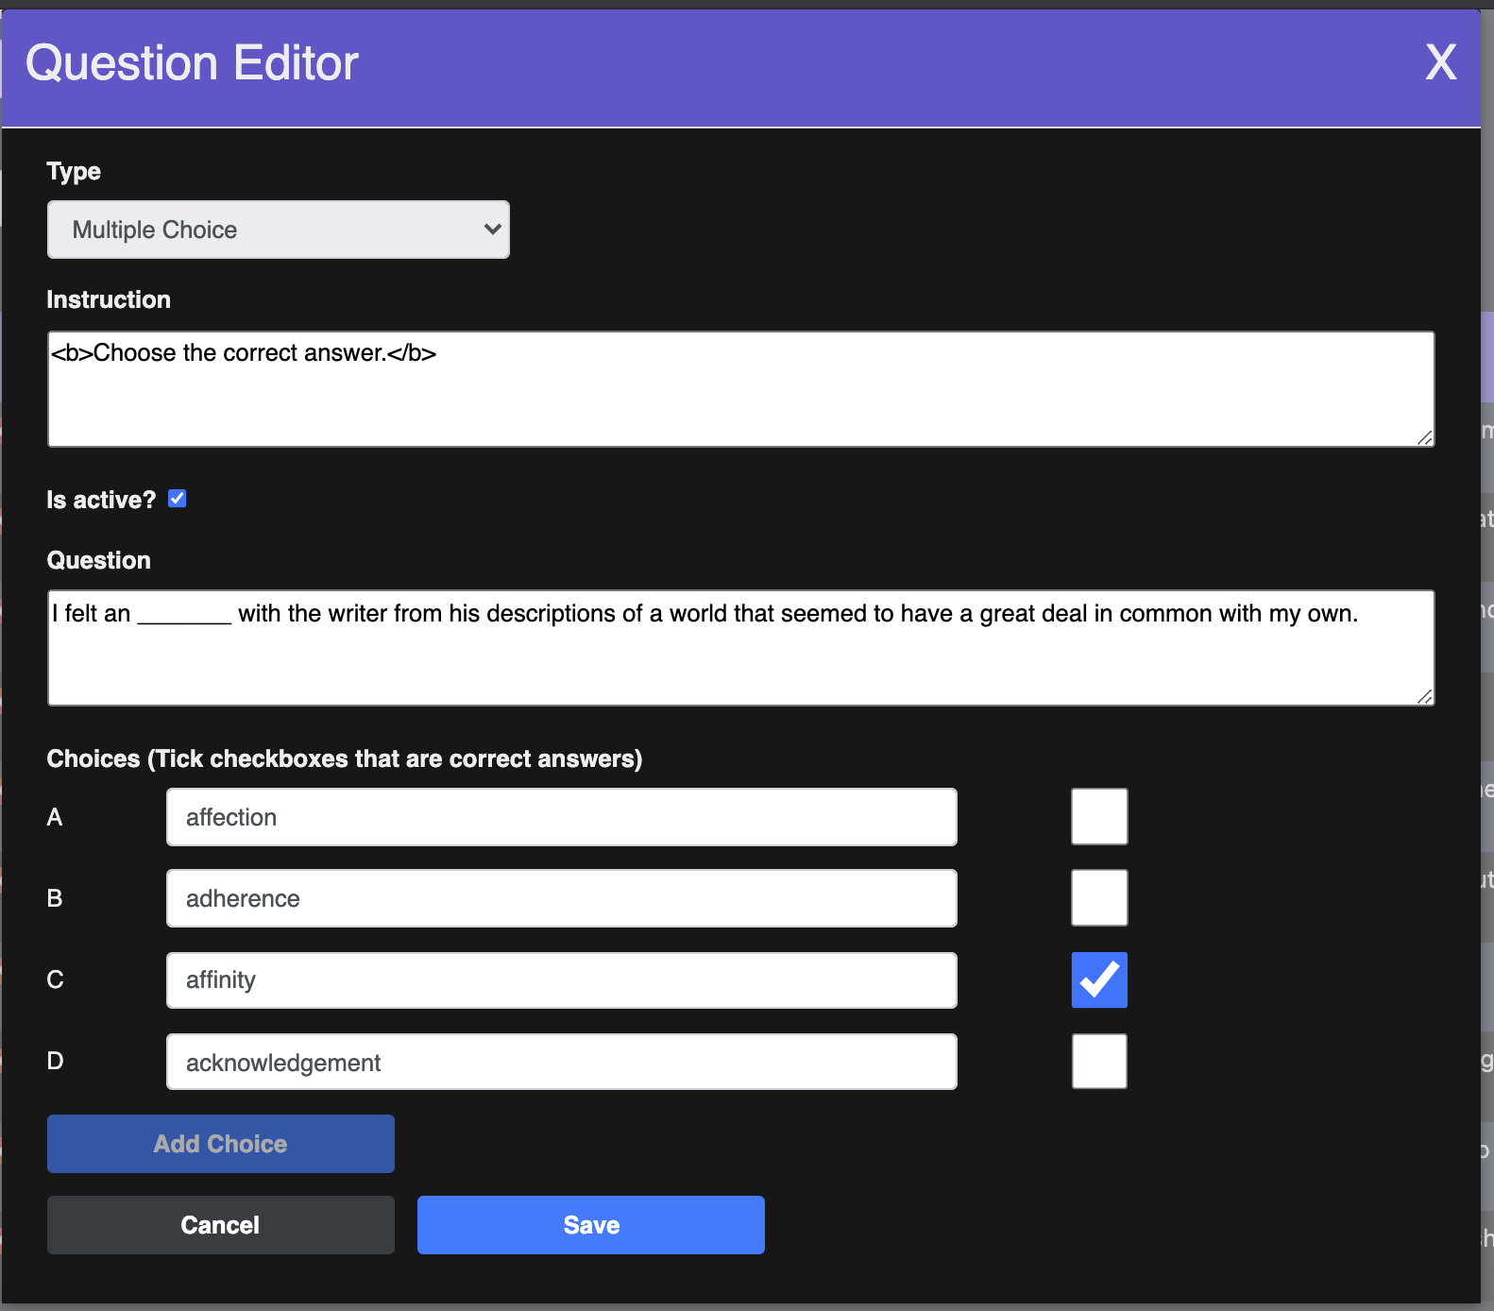

Figure : Teacher Screen - Add/Edit Multiple Choice Question

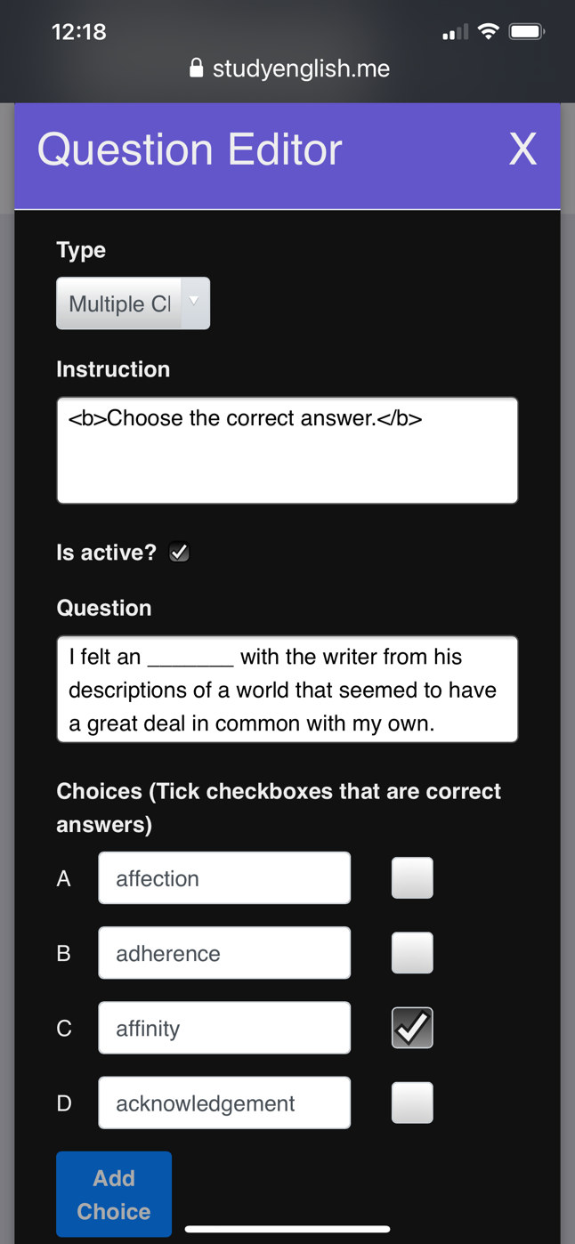

**Proposal:**

As soon as selects the edit button or the “Add Question” button, a modal named “Question Editor” will appear. Depending on whether the teacher is editing a question or creating a new question, the editable form will be filled in.

If the question is being edited, the teacher cannot change the type of the question because may be causing a lot of complex issues in the database and it is much more useful to create a new question with a different question type. All question types have the same input forms for Instruction, Question, and Active. While the first two will be displayed in the header of question card, the Active checkbox determines whether or not the question should be included in the quiz and shown to quiz takers.

As for the multiple-choice question type, teachers can add new choices by clicking on the “Add Choice” button and identify the correct answers by checking the boxes.

**Changes from proposal:**

* It had not been mentioned in the proposal, but once a question has been created, user is not allowed to add new choices, though they can change the texts of these choices and the question text and instruction. For current application, complicated SQL transactions are avoided, thus such edits should be left future versions of the app.

### **Teacher Screen – Add/Edit Question – Gap-filling Questions**

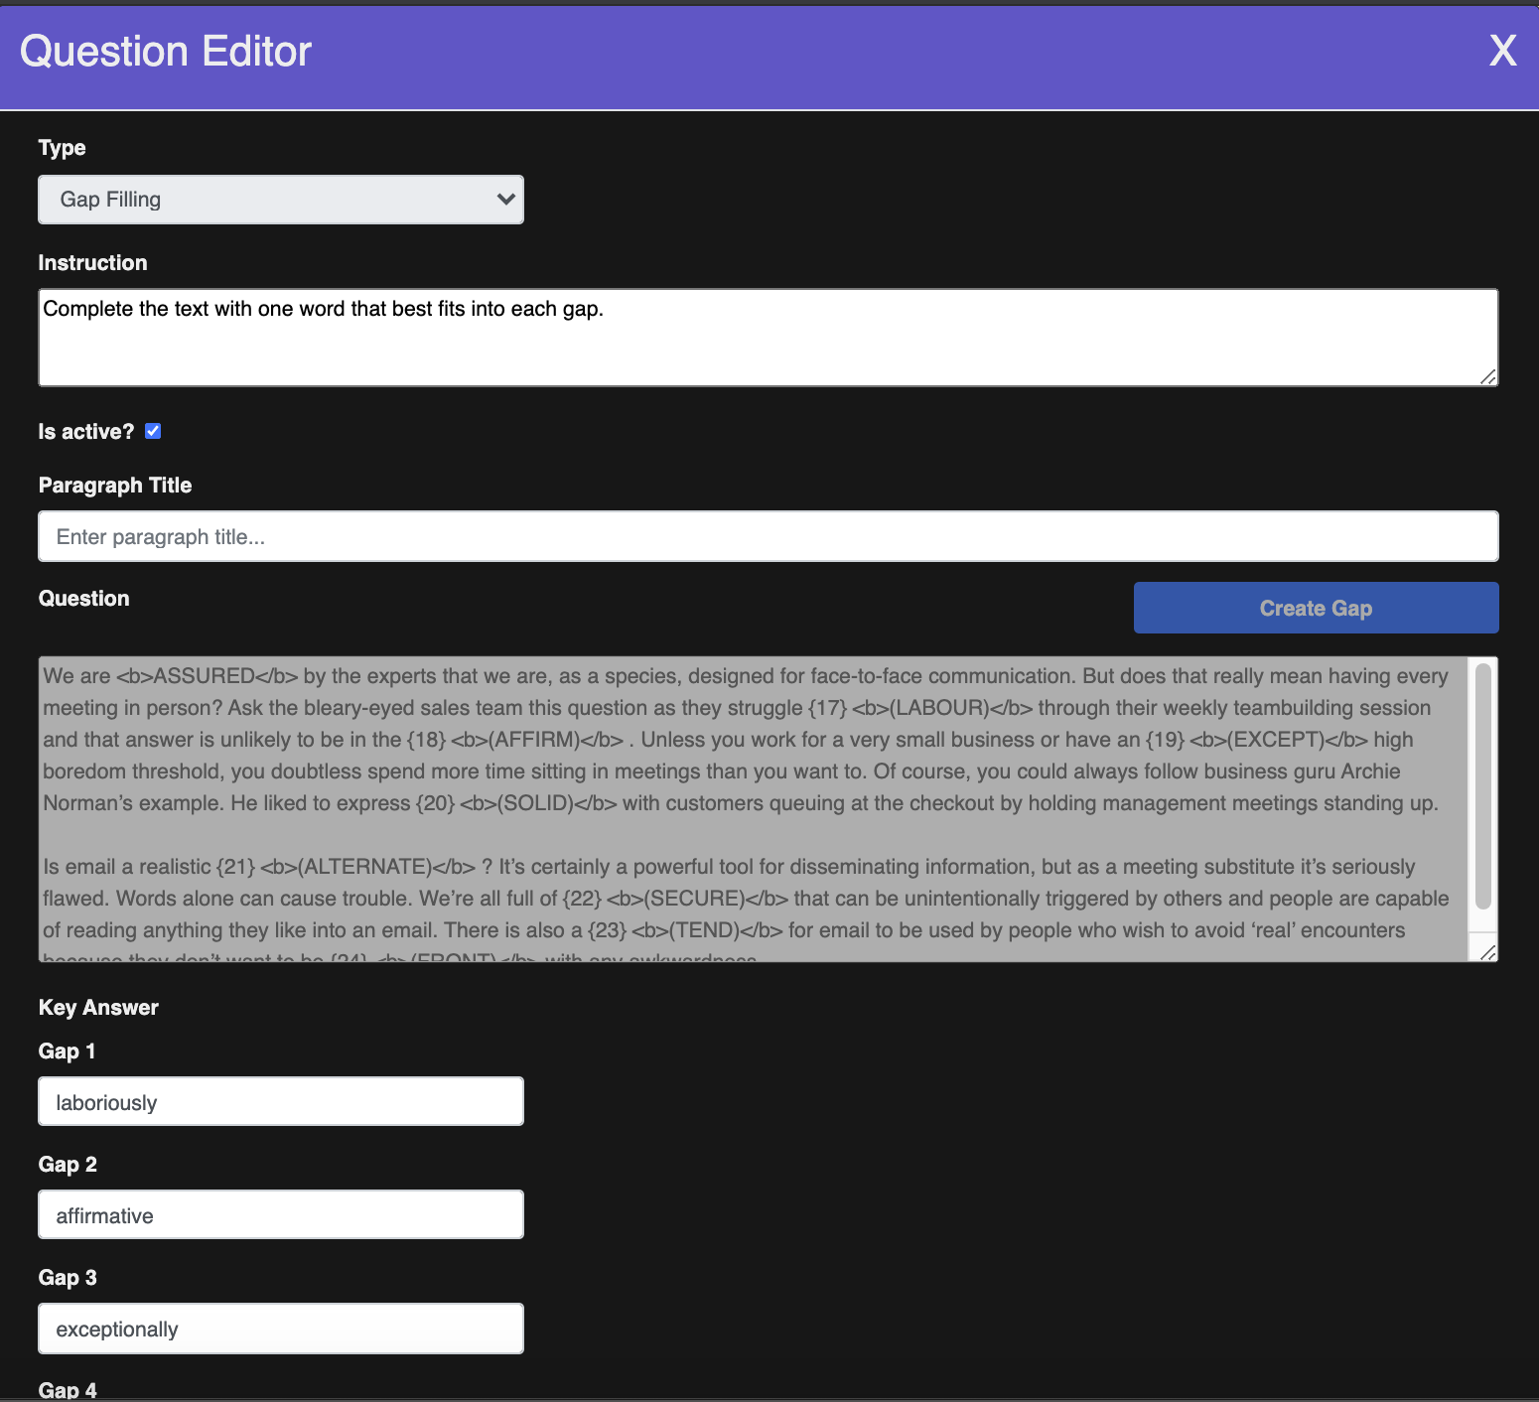

Figure : Teacher Screen - Add/Edit Gap-filling Question

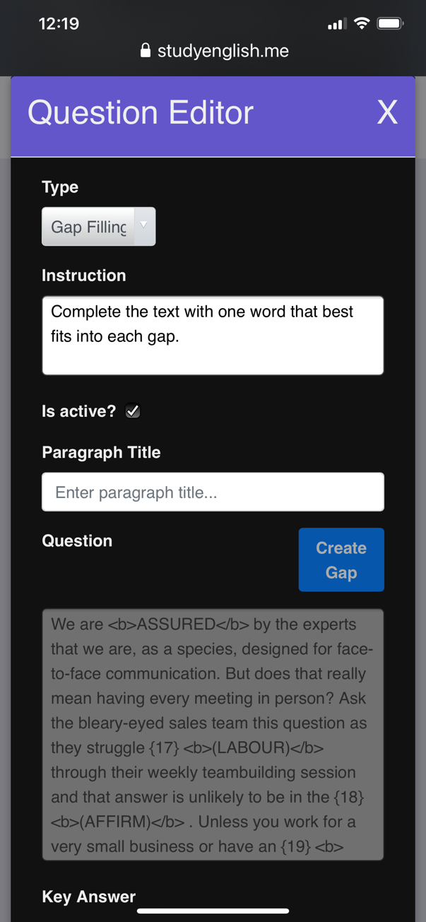

**Proposal:**

As for the gap filling question type, teachers create new gaps for filling in by using “Create Gap” button. By clicking on the button, a new series of special characters will be inserted into the text area for question to let the system know that is a blank for filling in. If teachers are not very happy about the blank, they can delete the gap by just deleting the special characters that have been created by the system. Also, as soon as teacher has created a gap, a new text input form will be also created for giving correct answer. There is also validation that ensures everything in the question text area in the proper format before the question is added to the database.

**Changes from proposal:**

* Like multiple choice questions, once the question has been created, user cannot create a new gap, but they could edit the texts of the current gaps.

### **Teacher Screen – Add/Edit Question – Matching Questions**

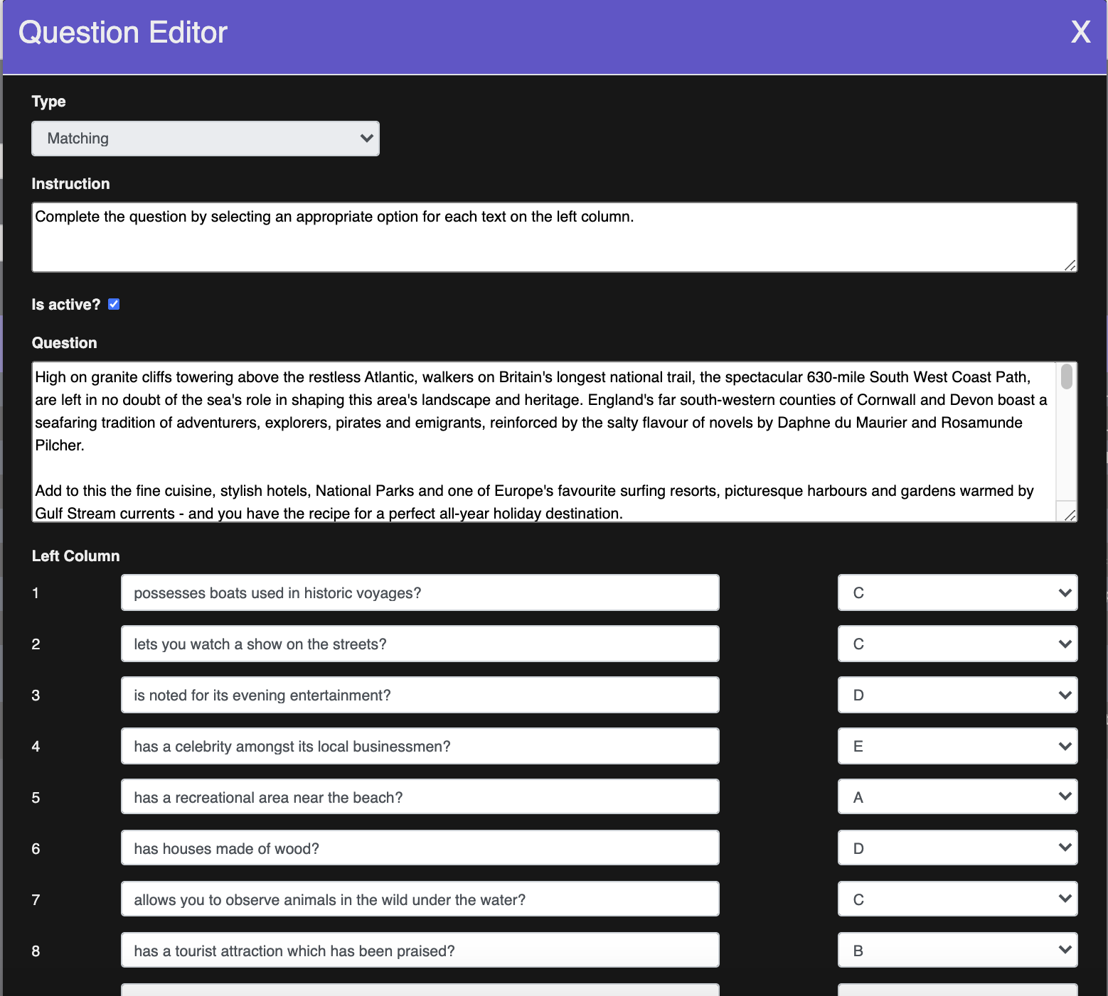

Figure : Teacher Screen - Add/Edit Matching Question

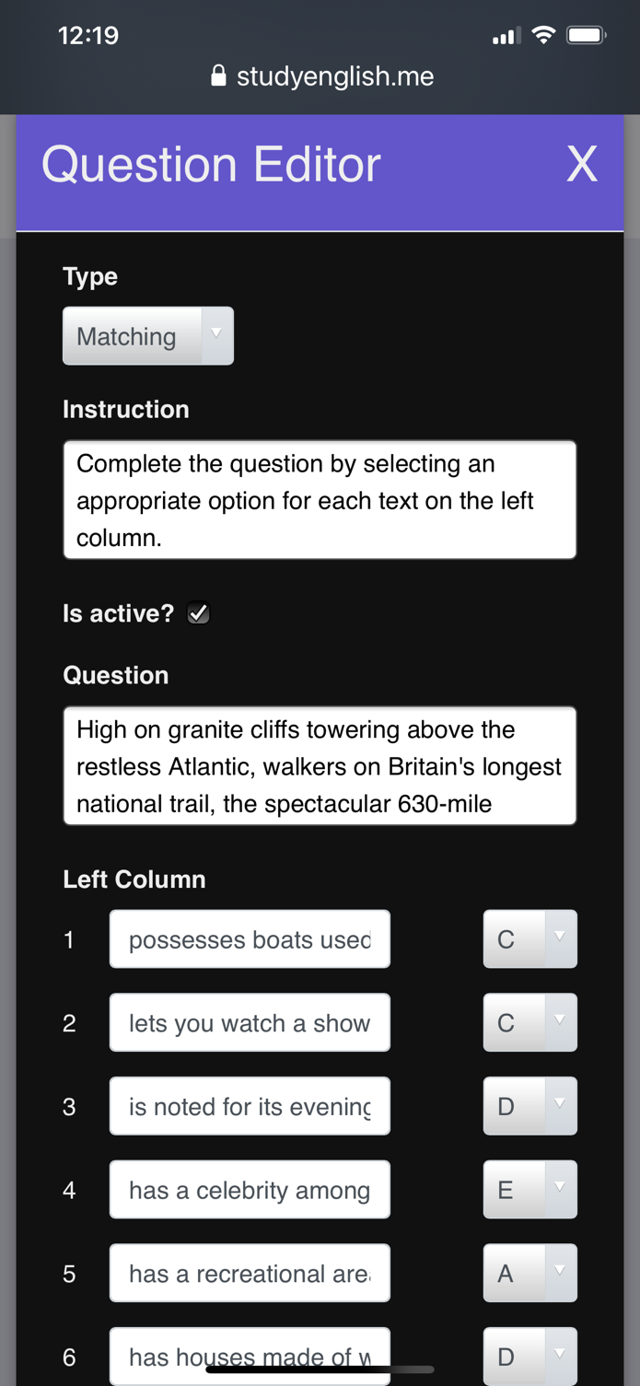

**Proposal:**

In regards to matching question type, teachers can create as many items as they want for left column and right column by using the “Add Item” buttons. However, there is validation that makes sure that all items in left column have corresponding responses from the right column. The dropdown boxes on the right-hand side of items in the left column are automatically updated when new items are added to the right column. Teachers can select any matching item for these dropdown boxes.

**Changes from proposal:**

* Like the other two types of questions, user cannot add items to left or right column once the question has been made, but they can edit the texts and change correct answers.

### **Board Statistics – View Statistics by Student**

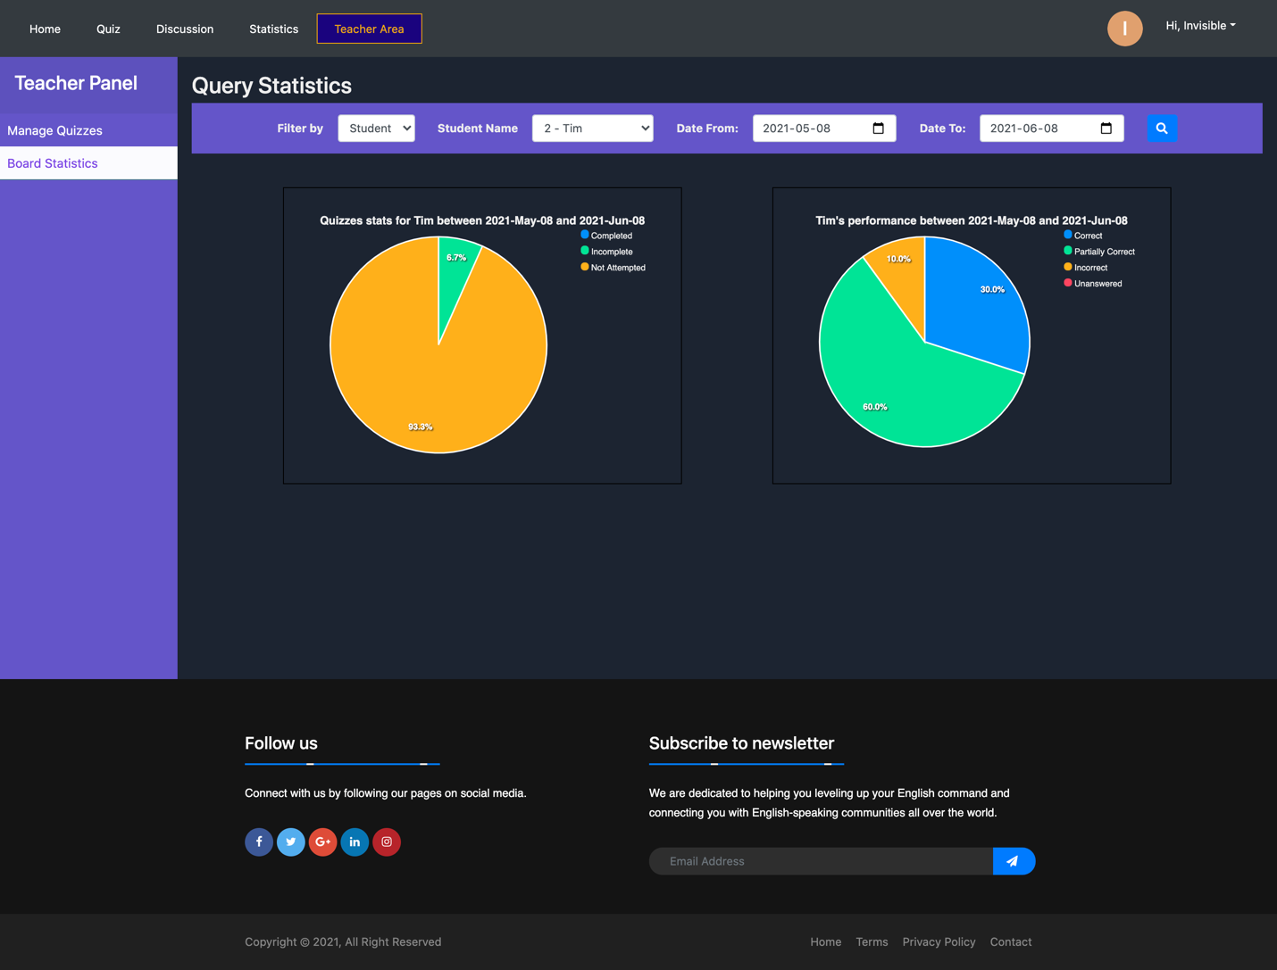

Figure : Teacher Screen - Board Statistics - View Statistics By Student

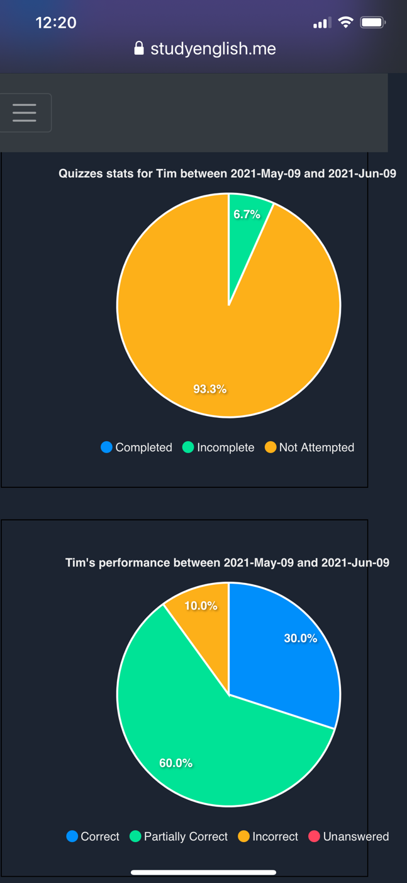

Figure : Query Statistics by Student

**Proposal:**

This screen can only be accessed by teachers. In the screen, teachers can view statistics by either “Student” or “Quiz” in the dropdown box.

If they choose to filter by “Student”, they will need to enter the student’s name using the input form next to “Student Name”. As soon as they have filled in the student’s name, selected the date range and clicked on Search, information about the number of completed, in progress, not attempted quizzes by the student within the date range will be populated in a pie chart.

**Changes from proposal:**

* Some small UI changes from proposal

Beside that is another pie chart that visualizes the number of correct, incorrect and unanswered responses to questions by the student within that date range.

### **Board Statistics – View Statistics by Quiz**

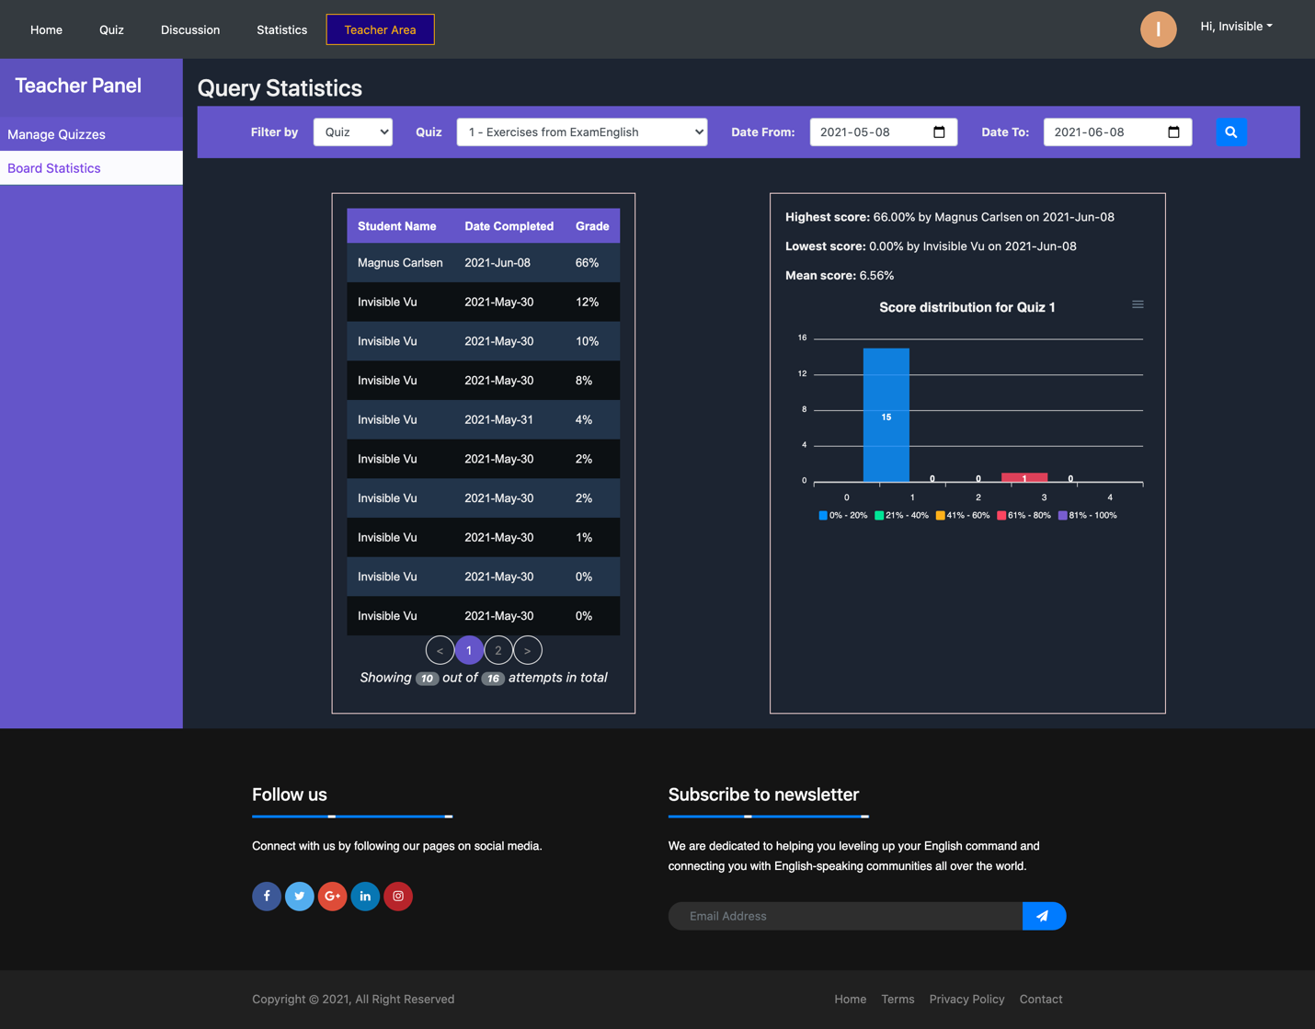

Figure : Teacher Screen - Board Statistics - View Statistics By Quiz

**Proposal:**

If they choose to filter by “Quiz”, they will need to select the quiz number using a dropdown box and enter the date range to view statistics for this quiz. As soon as they clicked on “Search” button, the list of student names who have completed the quiz will be populated in a paginated table along with completed dates and scores. Teachers can also view the overall statistics for the quiz, including the highest, the lowest and the mean score of the quiz. Below is a bar chart that visualizes students’ scores in five different score ranges.

**Changes from proposal:**

* No significant changes

# Extensions

There are many opportunities for this application to grow as a small start-up. Potential improvements could be:

* HTML editor for entering paragraph text, question
* Add more types of questions that are frequently seen in international English proficiency exams like multiple choice questions for a paragraph with many gaps and gapped texts
* Support uploading audio files for listening quizzes
* Machine learning models that can evaluate students’ essays
* Limit the content that can be accessible by students and unlock premium content only paid users

# Unit Testing

